Fall 2020 Honors Chemistry Final Review

Scientific Method – define the following
- Observation
- Hypothesis
- Experiment
- Data/Analysis
- Theory or Scientific Law
1. Honeybees play an important role in agriculture, by pollinating at least 90 different species of food plants, worth about 15 billion dollars in the U.S. alone. As a result, beekeeping or apiculture, is a multi-million dollar business. However, over the last year, honeybee populations are crashing (Colony Collapse Disorder) with hives dying off in less than a week, without an obvious cause. Ian Lipkin, a senior researcher in the Epidemiology (infectious disease) Department of Columbia University's Mailman School of Public Health believed the cause to be a pathogen (virus, bacteria or fungus) of some sort. Use the information given to answer the following questions.
- What is the initial observation?
- What is the hypothesis?
- Design an experiment to test your hypothesis.
- If you did your experiment and your hypothesis was supported, what would your data indicate?
- If you did your experiment and your hypothesis was NOT supported, what would your data indicate?

Scientific Notation – is a way of writing very large or very small numbers.
- To put a number into scientific notation, move the decimal point between the 1st two numbers so that it makes a number between 1 -10.
- Then, as × 10 raised to a power of how many times you moved that decimal point. The power will be negative if the number is a decimal and positive if it is a large number.
- Examples,
  - – Mass of a proton = 0.000 000 000 000 000 000 000 000 00 000 16726178g

    - Move the decimal point between the 1 and the 6 so you get … 1.6726178
    - Add × 10 to that and count how many times you moved your decimal point AND you should get…

    - 1.6726178 × 10⁻³⁰ g
  - Mass of the Eiffel Tower = 7300000000 g
    - 7.3 × 10⁹ g
2. Covert these measurements into or out of scientific notation.
a. 0.00000678s
b. 19100000J
c. 0.000546g
d. 12110000000°C
e. 8.76 × 10⁴atm
f. 3.42 × 10⁻⁴ mol

Nuclear Chemistry
3. Define the following (nuclear fission and nuclear fusion) and which one
a. produces the most elements?
b. is used in nuclear reactors?
c. is for fuel for stars where all the elements heavier than hydrogen are created?
d. requires extremely high temperatures?

States of Matter
4. Match each property to its correct state of matter.
a. solid
b. liquid
c. gas
d. plasma

- close-particles that can slide past each other
- free-moving (random) particles that are relatively far apart from each other
- closed-packed particles that cannot do much more than vibrate in position
- free-moving particles in which the electrons have been ripped off the atom, creating charged particles, occurs at high temperatures.
- Definite shape and definite volume
- No definite shape or volume
- Definite volume but not shape

- Physical Properties/Changes – can be observed without changing the substance’s composition. (It’s still the same substance!)
- Chemical Properties/Changes – can be observed when a substance changes composition. (Something new formed!)

5. Determine if the following properties/changes are physical or chemical.
a. Oxygen gas is odorless and colorless.
b. Copper turns green when exposed to the environment.
c. The density of water is 1.00g/cm³.
d. Copper conducts electricity.
e. Gold is nonflammable.
f. Baking soda reacts with vinegar.
g. The melting point of gallium is 85.6°F (30°C).
h. The silver spoons tarnished and turned black.

Pure Substances vs. Mixtures
Matter
Anything that takes
up space & has mass

Pure Substances Mixtures
Substance that Substance that
has definite & constant has variable
composition composition

Elements Compounds Heterogeneous Homogeneous
One type of 2 or more can see each blended, cannot
Atom atoms bonded component see each
together in mix component in mix

Examples
- element = iron, tungsten, chlorine
- compound = water, carbon dioxide, iron (III) chloride
- heterogeneous mix = Chex-mix, dirt
- homogeneous mix = air, soda, salt water

- Physical vs. Chemical
  - Properties (nouns) & Changes (verbs)
    - Physical properties and changes can be observed WITHOUT changing the substance’s composition
      - Examples – tearing, boiling, freezing, density, melting point, solubility
      - Can be used to separate mixtures by
        - Magnets
        - Size
        - Solubility (ability to dissolve)
        - Density
        - Filtration
        - Chromatography
        - Distillation
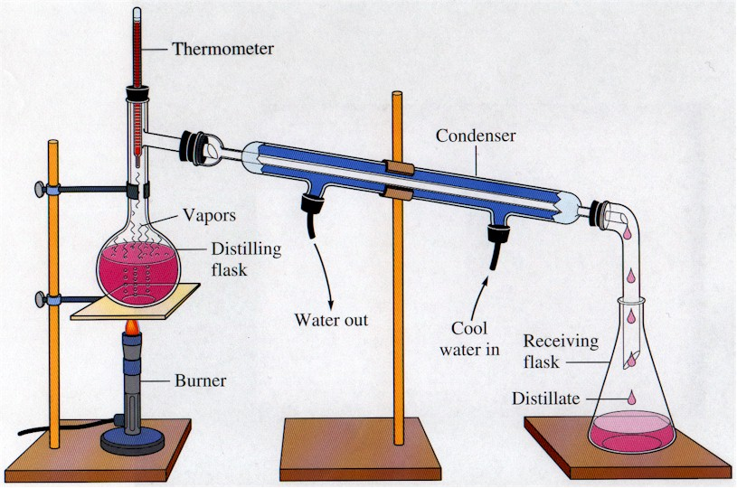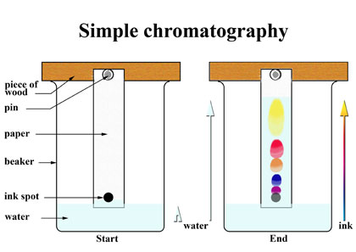

    - Chemical properties and changes can ONLY be observed by changing the substance into a completely NEW substance.
      - Examples – reactivity, flammability, rusting, digesting, decomposing, oxidizing
      - Can be used to change pure substances into new pure substances through chemical reactions

6. Determine if the following substances are elements, compounds, homogeneous mixtures or heterogeneous mixtures:
a. copper b. Lucky Charms cereal
c. air d. oxygen
e. carbon monoxide e. hot coffee

7. Determine if the following are chemical properties/changes or physical properties/changes:
a. A burning tire
b. Freezing ice cubes
c. The density of water is 1.0g/cm³.
d. Rubidium will catch on fire if dropped in water.
e. Platinum is a silvery-white color.
f. Copper (II) chloride dissolves in water.

8. If gallium melts at 29.78°C and boils at 2403.0°C, what is its state of matter at it is in your hand? Keep in mind that your normal body temperature is 37.0°C.

Nomenclature (Names and Formulas!)
See nomenclature flow charts on the blog or the included graphic organizer and polyatomic ion chart!

9. Write either the name or the formula for each substance. (This is NOT a matching exercise.) They can be any type: type I ionic, type II ionic, type III covalent, or acids.
a. sodium sulfide b. HCl
c. gold (III) fluoride d. N₂O₅
e. carbonic acid f. Ca(NO₃)₂
g. dihydrogen monoxide h. H₃PO₃
i. lead (IV) sulfate j. Fe₂(C₂O₄)₃
k. tetracarbon decahydride l. Mg(CN)₂
m. nitric acid n. KMnO₄
o. chromium (III) dichromate p. PBr₅

Chemical Reactions
- Evidence a chemical reaction has occurred. One of these pieces of evidence must be present to understand that a chemical reaction has occurred.
  - A precipitate occurs (that means a solid forms)
  - Bubbles form
  - Water forms
  - There is a change in energy (the substance gets hotter or colder)
- Writing skeleton equations- change the reactants and products into their formulas. Separate reactants from products by a yield sign (), and don’t forget the states of matter: solid (s), liquid (l), gas (g), and aqueous (aq).
  - Don’t forget the 7 diatomic elements: H₂, O₂, N₂, Cl₂, Br₂, I₂, F₂

- Balancing chemical equations – using subscripts to make sure you have the same number of atoms of each element on both the reactants and products sides of the equation.

10. Balance the equations below:
a. N₂ (g) + H₂ (g) NH₃ (g)
b. AlBr₃ (aq) + K₂SO₄ (aq) Al₂(SO₄)₃ (aq) + KBr (aq)
c. C₅H₁₂ (l) + O₂ (g) CO₂ (g) + H₂O (g)
d. Ag₂O (s) Ag (s) + O₂ (g)
e. Na (s) + Fe(NO₃)₃ (aq) Fe (s) + NaNO₃ (aq)

- 5 Types of Reactions
  - Synthesis – 2 or more reactants combine to make 1 product
  - Decomposition – 1 reactant breaks down into 2 or more products
  - Single-replacement – an element replaces another element in a compound
  - Double-replacement – 2 compounds switch ions
  - Combustion – a hydrocarbon reacts with oxygen gas to produce carbon dioxide and water

11. Identify the type of reaction for each equation in #10.

12. Predict the products for the following reactions:
a. decomposition AlF₃
b, single – replacement Na + Ti(NO₃)₃
c. combustion C₂H₆ + O₂
d. double – replacement H₂SO₄ + KOH
e. synthesis Ba + Cl₂

Moles
- Molar Mass – the sum of the atomic masses for each atom of each element in the compound
  - Example- Ca(NO₂)₂
Ca: 1 × 40.08g = 40.08g
N: 2 × 14.01g = 28.02g
O: 4 × 16.00g = 64.00g
132.10g

- % Composition – determine the % of each element by mass in a compound
  - % element = mass of element × 100
molar mass
  - Example – Find the % of each element in Ca(NO₂)₂. (I will use the molar mass example from above for this.) You can check your answers by adding your final %’s up, they should be very close to 100%.
    - %Ca = 40.08g × 100 = 30.34%
132.10g
    - %N = 28.02g × 100 = 21.21%
132.10g
    - %O = 64.00g × 100 = 48.45%
132.10g

14. Find the molar mass and % composition for all the elements in the following compounds:
a. CuBr₂ b. Co₂(CO₃)₃
c. Cr₃(PO₄)₂ d. SF₆

- Mole Calculations
  - Use your mole map to guide you in solving mole problems. Remember to always figure out your given and unknown first! That way you know where to start and where to end up on your mole map.

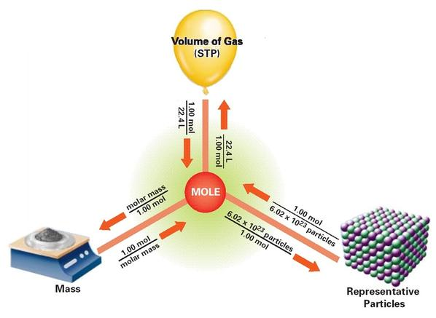
15. How many moles are in 34.5 g of water?

16. How many molecules are in 0.456 liters of water as steam?

17. How many moles are in 21.1g of calcium chloride?

18. How many moles are in 6.789 × 10²² formula units of calcium chloride?

19. How many atoms are in 99.99g of nitric acid, HNO₃?

20. What is the volume, in liters, of 7.87 × 10²⁵ molecules of sulfur trioxide?

- Empirical and Molecular Formulas
  - What’s the difference?
    - A molecular formula is the true formula for a substance, for example, tetraphosphorous decoxide is P₄O₁₀.
    - An empirical formula has the coefficients reduced down to their lowest possible ratio, for example, that P₄O₁₀ can be reduced to P₂O_{5.}

21. Write the empirical formula for the following substances. If it already is an empirical formula, let it be!
a. C₆H₁₄ b. C₃H₈
c. C₆H₁₂O₆ d. Co₂(CO₃)₃

22. Determine the empirical formula for a coconut oil, a compound that is 66.611% carbon, 11.204% hydrogen, and 22.185% oxygen.

23. Determine the empirical formula for isoamyl acetate, the scent of bananas. It is composed of 64.56% carbon, 11.06% hydrogen, and 24.58% oxygen.

Stoichiometry – determining how much product can be made from a specific amount of reactants. It is based on the law of conservation of mass and uses MOLE RATIOS to convert between substances!

- Mole ratio = moles of unknown
moles of given
- If you want to see a step by step procedure for doing stoichiometry, please go to your notes or the following website-http://misterguch.brinkster.net/stoichiometryexplained.pdf
- Limiting and Excess reactants
  - Limiting reactants control how much product can be made during a chemical reaction because you run out of that reactant first!
  - An excess reactant is one in which you have more than enough for the reaction to run to completion.

24. Use the balanced equation to answer the following questions:
3 K (s) + Au(NO₃)₃ (aq) Au (s) + 3 KNO₃ (aq)
- How many moles of potassium nitrate are produced from 21.0 moles of potassium?

- How many grams of gold are produced from the reaction of 1.50 moles of potassium with excess gold (III) nitrate?

- What is the mass, in grams of potassium nitrate produced from the reaction of 50.00g of gold (III) nitrate with excess potassium?

- Determine the limiting reactant if 30.00 moles of potassium reacts with 9.00 moles of gold (III) nitrate.
- Determine the limiting reactant if 1173g of potassium reacts with 3447g of gold (III) nitrate.

Atomic Structure
- Subatomic Particles
  - Inside the nucleus of an atom
    - Protons (p⁺)
      - Positively charged particles, charge = +1
      - # of protons in the nucleus identifies an element, is the atomic number
    - Neutrons (n⁰)
      - Particles with no charge, charge = 0
      - They maintain the stability of the atom, in a nuclear/radioactive sense.
    - Mass number = #p⁺ + #n⁰
      - Is ONLY the same as a round atomic mass if you are describing the most common isotope of that element!
        - Isotopes= are atoms of an element that have the same atomic number but different mass numbers (they have different #’s of neutrons!)
  - Outside the nucleus
    - Electrons (e⁻)
      - Negatively charged particles, charge = -1
      - Equals the # p⁺ in a neutral atom (not an ion)
      - They are involved in bonding atoms to form compounds

- Fill in the chart below. You may use your periodic table also.
Element | atomic # | mass # | # protons | # electrons | # neutrons
sulfur |  | 32
 | 48 |  |  |  | 64
 |  | 181 | 73
 |  |  |  | 99 | 153

- Electron Configurations – tell you the placement of the electrons within the energy levels (orbitals) and sublevels within the atom
  - The ground state is the lowest energy levels for the electrons and how we write electron configurations.
  - Sublevels- each type of sublevel can hold a different amount of electrons
    - s = 2 e⁻, p = 6e⁻, d = 10e⁻, f = 14 e⁻

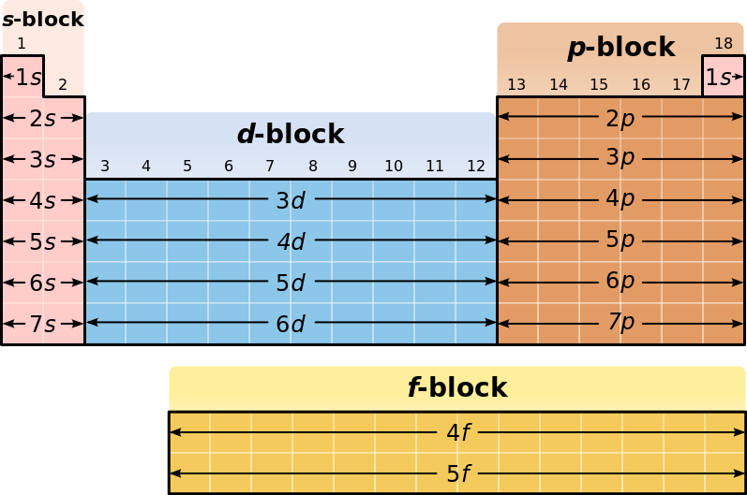
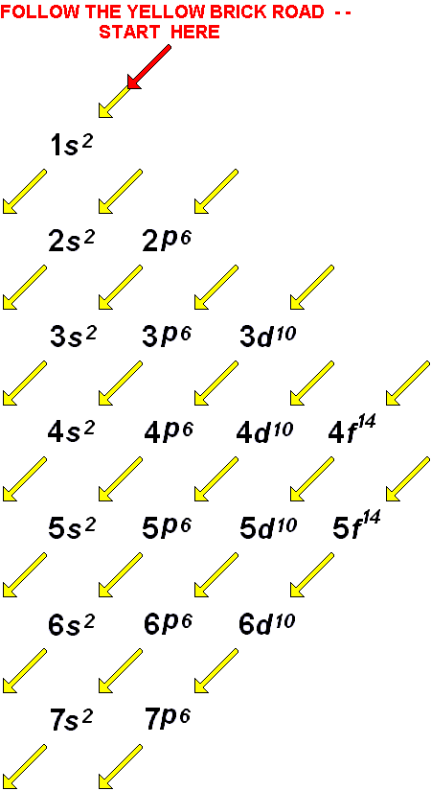

- Write ground state electron configurations for the following elements:
  - Ti c. Br
  - Ni d. Sr

- Electrons and Light
  - Electrons can give off light when they are excited. This means that the electron has absorbed energy and moved to a higher energy level where it is unstable. In order to become stable again and move back down to the ground state, the electron releases a photon of energy. This photon has a wavelength and a frequency in the visible light spectrum that we can see. We use this to identify elements (Remember the Flame Test Lab?) and to determine the age of starts. We also use this property to make colorful fireworks!
    - The lower the wavelength, the higher the frequency and the more energy the photon has!
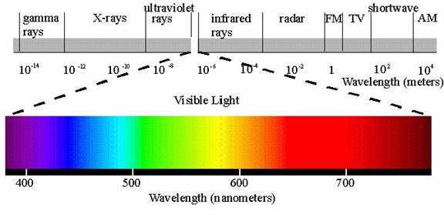

c = λ×ν E = h×ν
c = 3.00 × 10⁸ m/s h = 6.626 × 10⁻³⁴ J·s
- Which color of visible light has the highest frequency? Which color has the lowest frequency? How do you know?

- Which color of visible light has the highest energy? Which color has the lowest frequency? How do you know?

Chemical Bonds
- Ionic Bonds – occur between a metal and a nonmetal
  - An electron is transferred from the metal to the nonmetal
    - The metal becomes + charged and the nonmetal becomes – charged.
    - Shown by drawing electron dot diagrams
  - Very strong bonds, takes a LOT of energy to break an ionic bond. Therefore, ionic compounds are hard crystals with very high melting and boiling points!
- Covalent Bonds- occur between 2 nonmetals
  - An electron is shared between the 2 nonmetals because neither one is strong enough (has a high enough electronegativity) to take the electron from the other element.
    - Shown by drawing Lewis structures
  - Strong bonds but not as strong as an ionic bond so these compounds have lower melting and boiling points.

- Determine if the following compounds have ionic or covalent bonds, or both ionic and covalent bonds. Draw Lewis structures for a and c.
  - CO₂
  - FeF₂
  - NH₃
  - CaBr₂
  - MgSO₄
  - KC₂H₃O₂

Periodic Table and Periodic Trends
- Label the periodic table legend below with the following:
Noble gases, alkali metals, transition metals, halogens, inner transition metals, alkaline earth metals, metalloids

- What are groups on the periodic table and how many are there?

- What are periods on the periodic table and how many are there?

1
2
3
4
5
6
7
legend

- Periodic Trends
  - When the periodic table is set up as it is, properties of the elements show reliable trends. So it is possible to predict how an element is going to react or act based on its location on the periodic table.
  - In class, we discussed 3 properties: atomic radius, ionization energy (energy needed to remove an electron from the atom) and electronegativity (the attraction the nucleus of an atom has for another atom’s electrons).
    - Francium (Fr) vs. Fluorine (F)
 | Fr | F
atomic radius | largest | smallest
ionic radius | largest | smallest
ionization energy | smallest | highest
Electronegativity | smallest | highest

- Based on the information above, rank these elements, Sc, Br, and Ni, in order of
  - Increasing atomic radius
  - Decreasing ionic radius
  - Increasing ionization energy
  - Decreasing electronegativity

- Based on the information above, rank these elements, Se, Pb, and F, in order of
  - Increasing atomic radius
  - Decreasing ionic radius
  - Increasing ionization energy
  - Decreasing electronegativity

Kinetic Molecular Theory and States of Matter
- Assumptions of the Kinetic Molecular Theory
  - Gases particles are very tiny and are relatively far apart from each other
  - Collisions between gas particles is elastic- no energy is lost or gained in the collision
  - Gas particles are in constant, rapid, random motion
  - There is no attraction between the gas particles, they ignore each other
  - The temperature of the gas is a measure of the average kinetic energy of the gas particles.
- Atmospheric pressure – the force of the atmosphere pressing down on the earth.
- Evaporation and Boiling
  - A liquid evaporates at the surface of a liquid when some of the liquid particles gain enough kinetic energy to break free from the liquid state and become a gas.
  - Boiling occurs when the pressure created by the gas particles that just escaped from the liquid equals the atmospheric pressure
Heat
- Flow of energy from a higher temperature to a lower temperature
- Measured in joules (J) or calories (cal) or kilocalories (Cal)
- Exothermic vs Endothermic Processes
  - Exothermic processes – occur when heat is released from the system into the surroundings.
  - Endothermic processes – occur when heat is added to the system from the surroundings.

- On a cold day outside watching a football game, you decide to get a huge hot chocolate to hold.
  - If the hot chocolate is the system, is it endothermic or exothermic?
  - If your hands are the system, are they endothermic or exothermic?
- In lab, you add some nitric acid to water and notice that the beaker gets warm, is this an endothermic or exothermic process?
- In the summer, plants produce glucose (their energy source) by reacting carbon dioxide, water and heat and light from the sun. Is this process, endothermic or exothermic?

- Hess’s Law
  - If you reverse a reaction, change the sign of ∆H
  - If you multiply an equation, don’t forget to multiply ∆H

- Calculate ∆H for the reaction, PCl₅ (g) PCl₃ (g) + Cl₂ (g) from the information below:
  - P₄ (s) + 6Cl₂ (g) 4PCl₃ (g) ∆H_{a} = -2439kJ
  - 4PCl₅ (g) P₄ (g) + 10Cl₂ (g) ∆H_{b} = +3438kJ
- Calculate ∆H for the reaction, N₂H₄ (l) + H₂ (g) 2NH₃ (g) from the information below:
  - N₂H₄ (l) + CH₄O (l) CH₂O (g) + N₂ (g) + 3H₂ (g) ∆H_{a} = -37kJ
  - N₂ (g) + 3H₂ (g) 2NH₃ (g) ∆H_{b} = -46kJ
  - CH₄O (l) CH₂O (g) + H₂ (g) ∆H_{c} = -65kJ
- Calculate ∆H for the reaction, 2C₂H₄O (l) + 2H₂O (l) 2C₂H₆O (l) + O₂ (g) from the information below:
  - C₂H₆O (l) + 3O₂ (g) 2CO₂ (g) + 3H₂O (l) ∆H_{a} = -685.5kJ
  - C₂H₄O (l) + 5/2 O₂ (g) 2CO₂ (g) + 2H₂O (l) ∆H_{b} = -583.5kJ

- Calculating heat
  - q = mC∆T
    - If q is negative, it’s an exothermic process
    - If 1 is positive, it’s an endothermic process

- A 15.75g piece of iron absorbs 1086.75 J of heat and its temperature changes from 25°C to 175°C. Calcuate the specific heat capacity of iron.
- How much heat is needed to raise the temperature of a 2300.g aluminum lawn chair from 2°C to 16°C? The specific heat capacity of aluminum is 0.90J/g°C.
- How much heat is released when 454g of zinc are cooled from 96.0°C to 28.0°C? The specific heat capacity of zinc is 0.386J/g°C.

Solutions
  - Factors that affect the rate at which a solute can dissolve in a solvent
    - 1.
    - 2.
    - 3.
    - 4. Why do each of these factors affect how fast the solute dissolves?

  - Solubility Graph
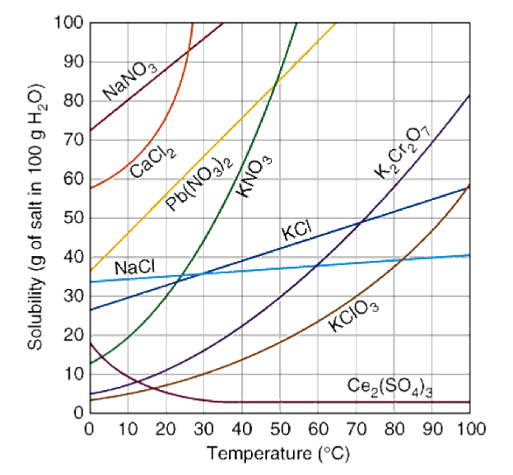

- How much potassium nitrate will dissolve in 100g of water at 70°C?
- How much lead (II) nitrate will dissolve in 200g of water at 60°C?
- If you dissolve 20g of potassium dichromate in 100g of water at 50°C, is the solution unsaturated, saturated, or super saturated?

  - Molarity – a measure of concentration
    - M = n/V
      - n = moles of solute, V = volume of solution in L
    - Dilutions
      - M₁V₁ = M₂V₂

- Calculate the molarity if you dissolve 15.0g of Mg(OH)₂ in 400mL of water.
- How many liters of water were used to create a 0.76M solution of HCl using 5.00g of HCl?
- What mass of NH₃ was used to create a 1.23M solution that has a volume of 1.00L?
- What is the new molarity of a 2.00L solution made by add water to 1.20L of a 0.856M solution of KCl?

- Colligative Properties – properties of a solution that depend only on the number of particles in solution not what the solute is.
    - Boiling Point Elevation – adding a solute to a solution raises the boiling point of the solution because
    - Freezing Point Depression – adding a solute to a solution lowers the freezing point of the solution because

- If you increase the number of solute particles in a solution, what will happen…
  - To its boiling point?
  - To its freezing point?

- Acids and Bases
- According to Arrhenius, what is the definition of an acid? A base?
- According to Bronsted- Lowry, what is an acid? A base? A conjugate acid? A conjugate base?
- Write which of the substances is a B.L. Acid, B.L. Base, Conjugate Acid, and Conjugate Base:
  - H₂O + H₂SO₄ H₃O⁺ + HSO₄⁻
  - H₂O + NH₃ OH⁻ + NH₄⁺
- What is the difference between a strong acid and a weak acid? Name 7 strong acids. Name 8 strong bases.
- Are the following solutions acidic or basic?
  - A solution of NaOH with a pH = 10.5
  - A solution of NaOH with a pH = 6.7
  - A solution of HC₂H₃O₂ with a pH = 4.6
  - A solution of HC₂H₃O₂ with a pH = 7.2
- Titrations (Neutralization), M_{A}V_{A} = M_{B}V_{B}
  - For the titration between KOH and HCl, determine the volume of 0.75M KOH you would need to titrate 0.0250L of 0.85M HCl.
  - How much 1.23M HCl would you need to neutralize 45.0 mL of a 0.990M LiOH solution?

