CW: Molarity Problems

Name:
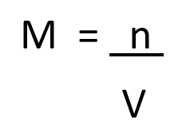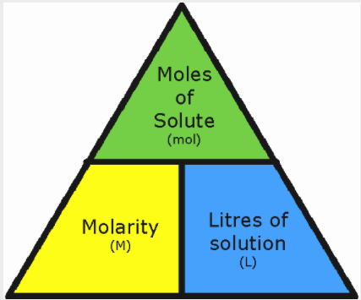

- Explain, in words, what molarity means.

- What is the molarity of a 0.30 L solution containing 0.50 moles of NaCl?

- Calculate the molarity of 0.289 mol of FeCl₃ dissolved in 0.120 L of solution.

- If a 0.0705 L solution contains 26.00 g of CuCO₃, what is the molarity?

- How many moles of Na₂S are in 0.600 L of a 1.55 Molar solution?

- What mass of H₂SO₄ is present in 1.63 L of a 0.954 Molar solution?

- Explain how you would make a 0.60 Molar solution of copper (II) nitrate in a 1.00L container, starting with the mass of copper (II) nitrate you need.

