CW: Dilution Calculations

Name: Period:

Directions: Solve each problem, show all your work and circle your answer written with correct significant figures and units.

M₁V₁ = M₂V₂

- A stock solution of 1.00 M NaCl is available. How many milliliters are needed to make 0.100L of 0.750 M

- What concentration of 0.250 L KCl is needed to make 0.100 L of 0.100 M solution?

- Concentrated H₂SO₄ is 18.0 M. What volume is needed to make 2.00 L of 1.00 M solution?

- Concentrated HCl is 12.0 M. What would be the molarity of a new HCl solution if you used 100.0mL of concentration HCl and diluted it to 0.350 L?

- What was the original concentration of a HClO₄ solution if 0.0500 L was used to make 0.150 L solution with a concentration of 0.890M?

CW: Colligative Properties

Name:____________________________________________________________________

Directions: Using your knowledge of colligative properties, answer the questions below.

- Why does adding antifreeze to your car help keep the water in your car’s radiator from boiling away on really hot days in Atlanta?
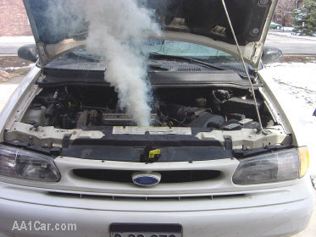

- When you make homemade ice cream, you always add “ice cream” salt or rock salt to the ice and it lowers the freezing point of the water so that the cream mixture in the inner container will freeze. How does that happen?
