Thermochemistry and Gas Laws Test Review

- Hess’s Law
  - Calculate ΔH for the reaction: P₄O₆ (s) + 2O₂ (g) P₄O₁₀ (s) given the information below.
    - P₄ (s) + 3O₂ (g) P₄O₆ (s) ΔH = -1640.1 kJ
    - P₄ (s) + 5O₂ (g) P₄O₁₀ (s) ΔH = -2940.1 kJ

  - Calculate ΔH for the reaction: CO (g) + 2H₂ (g) CH₃OH (g) given the information below.
    - 2C (s) + O₂ (g) 2CO (g) ΔH = -537 kJ
    - 2C (s) + O₂ (g) + 4H₂ (g) 2CH₃OH (g) ΔH = -402.4 kJ

  - Calculate ΔH for the reaction: C₂H₄ (g) + 6F₂ (g) 2CF₄ (g) + 4HF (g) given the information below.
    - H₂ (g) + F₂ (g) 2HF (g) ΔH = -537 kJ
    - C (s) + 2F₂ (g) CF₄ (g) ΔH = -680 kJ
    - 2C (s) + 2H₂ (g) C₂H₄ (g) ΔH = +52.3 kJ

  - Calculate ΔH for the reaction: N₂O (g) + NO₂ (g) 3NO (g) given the information below.
    - N₂ (g) + O₂ (g) 2NO (g) ΔH = +180.7 kJ
    - 2NO (g) + O₂ (g) 2NO₂ (g) ΔH = -113.1 kJ
    - 2N₂O (g) 2N₂ (g) + O₂ (g) ΔH = =163.2 kJ

- Heat – use the equation q = mCΔT (ΔT = T_{final} – T_{initial}) to solve the following problems.
  - The specific heat capacity of octane is 2.22 J/gK. How much heat energy is required to raise the temperature of 80.0g of octane from 10.0°C to 25.0°C? Is this process endothermic or exothermic?

  - A 45.0g block of copper is cooled down from 30.0°C to 15.0°C. The specific heat capacity of copper is .385 J/g°C. How much heat energy is released? Is this process endothermic or exothermic?

  - 1500.J of heat is released when 99.88g of magnesium is cooled. The specific heat capacity of magnesium is 1.020 J/g°C. What is the change in temperature of the magnesium?

- Heating Curves
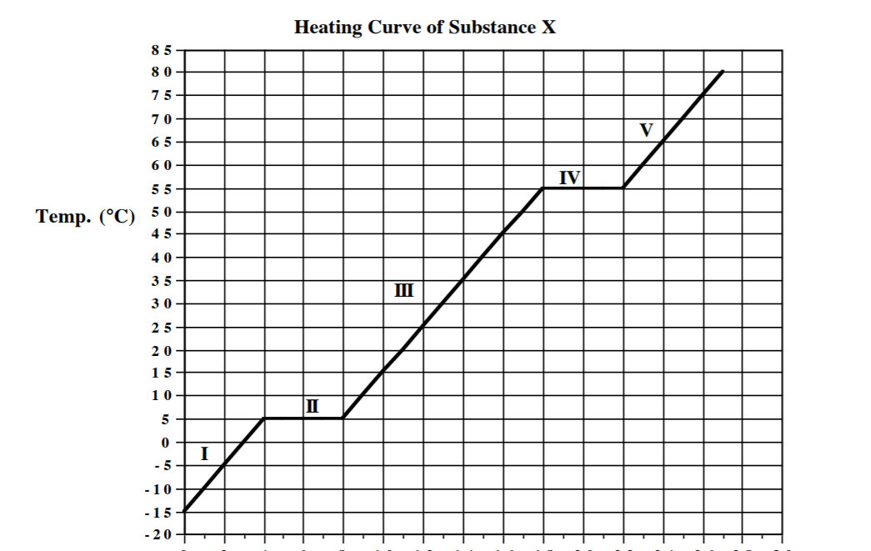
Heat Added
  - What state or states of matter exist at line segment I? What happens to the heat energy being added?
  - What state or states of matter exist at line segment II? What happens to the heat energy being added?
  - What state or states of matter exist at line segment III? What happens to the heat energy being added?
  - What state or states of matter exist at line segment IV? What happens to the heat energy being added?
  - What state or states of matter exist at line segment V? What happens to the heat energy being added?
  - What is the melting/freezing point of this substance?
  - What is the boiling/condensing point of this substance?

- Gas Laws
Boyle’s Law Charles’s Law Gay-Lussac’s Law Ideal Gas Law
P₁V₁ = P₂V₂ V₁T₂ = V₂T₁ P₁T₂ = P₂T₁ PV = nRT
R = .08206 L·atm/mol·K

Units of temperature T_{Kelvin} = T_{Celsius} + 273
- Draw a simple graph to represent Charles’ and Gay-Lussac’s laws and explain what the graph means.
  - For example Boyle’s Law – The graph below show that as the volume increases, the pressure decreases.

- For each problem, determine which law you would use to solve the problem and then solve it!

  - If 5.00L of neon gas is cooled from 24.0°C to -272°C, what is the new volume of the gas?

  - If .214 atm of argon gas has a temperature of 200.0°C, what would the temperature of of argon gas with a pressure of 375.0°C occupy?

  - If the pressure exerted on the gas in a weather balloon with a volume of 33.0 L decreases from 1.00 atm to .562 atm, what is the new volume of the weather balloon?

  - 19.00. L of carbon dioxide gas 777°C. If some gas leaks out of the container so that its volume is now 1.200L, what is the temperature of the gas still in the container?

  - A balloon was filled with 1.234L of helium gas to a pressure of .3456atm. What is the pressure in the balloon is the volume is increased to 2.345L?

  - A 3.00 L container is filled with dinitrogen monoxide gas at 25.00°C. The container doubles in size. What is the new temperature inside the container?

  - At what temperature does 16.3 g of nitrogen gas have a pressure of 1.25 atm in a 25.00L tank?

  - What will the volume of a balloon filled with a sample of krypton gas be if 100.0 g of krypton is at -99.66°C at a pressure of 0.955?

