Astronomy Stars Study Guide

Directions: Complete the following questions. The problems are in the text book.
- Describe some ways in which a cool star can be more luminous than a hot star.

- How do astronomers know that white dwarfs are really small?

- 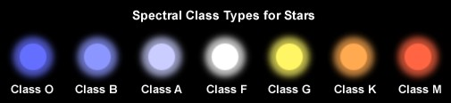Which stars are the hottest and which are the coolest? What class is the Sun?

- What is the H-R diagram and why is it useful.

- Describe the process by which protostars convert gravity into thermal energy.

- Describe the four different was a giant molecular cloud can be triggered to contract.

- What is the principle of hydrostatic equilibrium as it relates to the internal structure of a star.

- Explain why a star’s life expectancy depends on mass?

- Why does expanding stars become cooler and more luminous?
- Why can’t massive stars generate energy from Fe fusion?

- What are white dwarfs?

- How do white dwarfs form?

- How are planetary nebulae different from stellar nebula.

- Describe the way the sun will die.

- Describe everything that happens during a supernova.

- What are neutron stars and what force keeps them from collapsing?

- Describe a neutron star and how it forms.

- What are black holes and how do they form?

- If you were near the event horizon for a black hole, what is the scientific term for gravity’s effect on your body stretching you out into a very long noodle?

- Which stellar remnant has the lowest gravity: white dwarf, neutron star, or black hole? Which has the highest gravity?

- What are pulsars?

- Diagram the cores and energy transfers of a high mass star vs a low mass star.

- Why are massive stars described as element factories? In other words, how do they produce so many different elements?

