Electromagnetic Spectrum

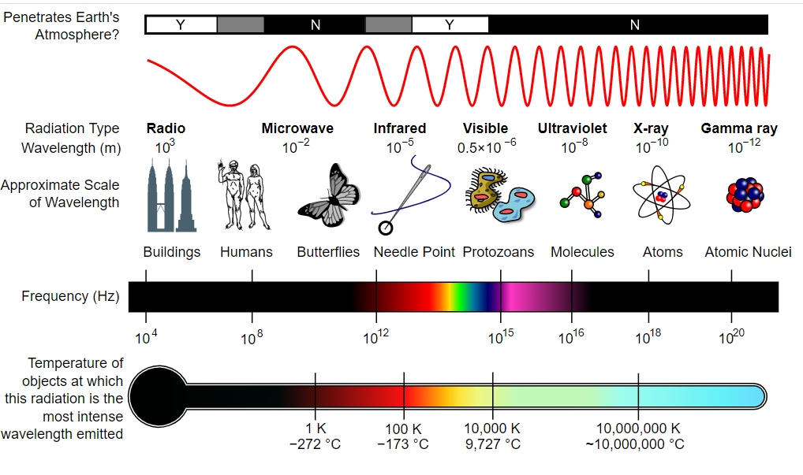

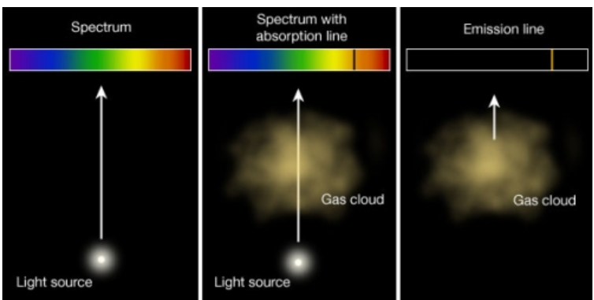

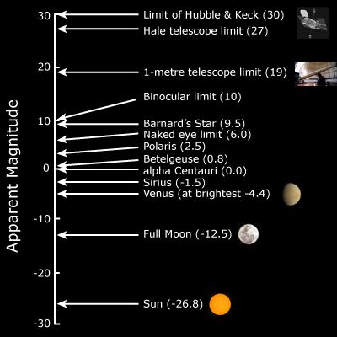

9. Luminosities of Stars – The Magnitude System

Brightness does not mean the star is close to us. Bright stars can be far away and dim stars can be closer to us.

8. The Doppler Shift: causes a change in the wavelength of light & is a tool for measuring the speed and direction of motion of astronomical objects.

