Name: Period:
CW - Electrons and Light

Directions: Answer each question fully.

- Determine if the statement is true or false: All electromagnetic radiation travels at different speeds.

- Define wavelength.

- Draw and label 2 waves: one with a large wavelength and one with a small wavelength.

- Define frequency.

- Draw and label 2 waves: one with a high frequency and one with a low frequency.

- How are the wavelength of light and the frequency of light related to each other?

- Which color of light has the highest frequency? Lowest frequency?

- Which color of light has the largest wavelength? Smallest wavelength?

- Describe how light can act as a particle.

- What is a photon?

- What happens to the electrons in an atom when energy is initially added to an element?

- Why and how do elements emit colored light?

- How can the color of light produced by an element identify that element?

c = λ × ν E = h × ν
c = 3.00 × 10⁸ m/s h = 6.626 × 10⁻³⁴ J·s

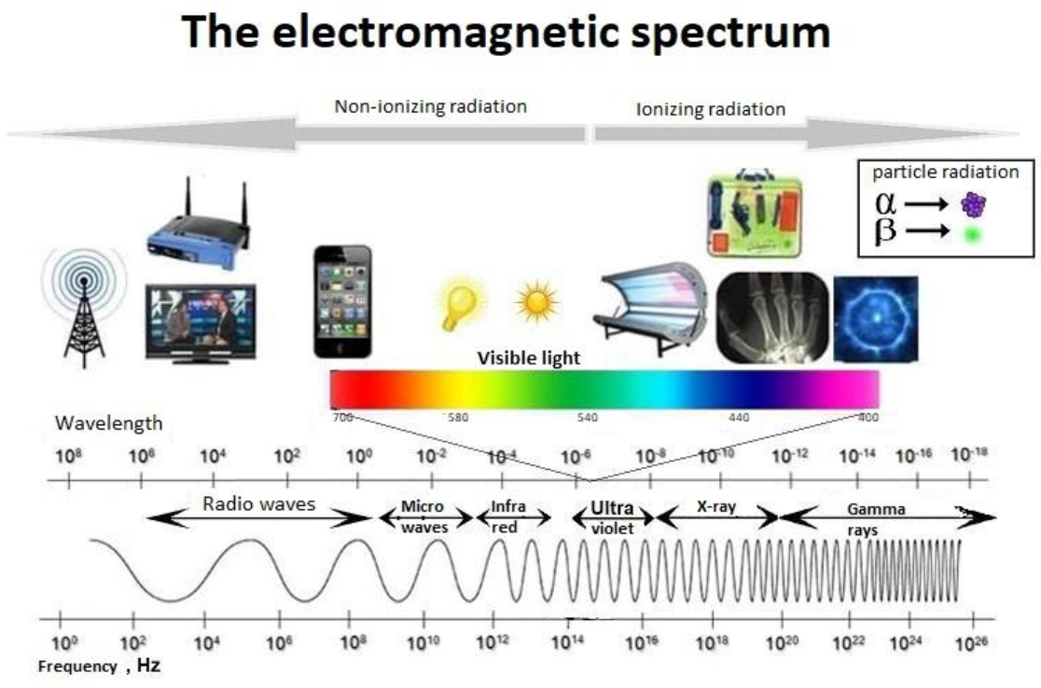

- Yellow light has a longer wavelength than green light. Which color of light has the higher frequency?

- Green light has a lower frequency than blue light. Which color of light has a longer wavelength?

