KEY - Forensic Science Final Exam Review

- What is an observation and how does it differ from an inference?
  - An observation is what a person perceives (interpreting information) using their senses. An inference is a conclusion based on the evidence or reasoning (which isn’t necessarily fact).

- What factors may influence an eyewitness?
  - Level of interest, stress, concentration, amount and kind of distractions present, prejudices, personal beliefs, and motives.
- How reliable is eyewitness testimony?
  - While eyewitness testimony can be powerful in swaying a jury, they are not extremely reliable. People’s memories fade over time and their brains “fill in” details that may not be accurate. On top of that, all the factors mentioned in questions #2 can alter a person’s beliefs on what happened.
- Define forensic science.
  - The application of scientific principles and techniques to matters of criminal justice especially as relating to the collection, examination, and analysis of physical evidence. It’s strictly concerned with uncovering evidence that stand as fact.
- Summarize Locard’s exchange principle.
  - When a person comes into contact with an object or another person, a cross-transfer of evidence can occur. The intensity, duration, and nature of the materials in contact determine the extent of the material transferred.
- Distinguish between direct and circumstantial evidence.
  - Direct evidence – evidence that (if true) proves an alleged fact, includes firsthand observations such as eyewitness accounts or police dashboard video evidence.
  - Circumstantial evidence – (indirect evidence) evidence used to imply a fact but not prove it directly. Can be biological or physical. Physical evidence can be fingerprints, footprints, shoe impressions, tire impressions, tool marks, fibers, weapons, bullets, and shell casings. Biological evidence can be body fluids, hair, plant parts, and natural fibers
- Describe how evidence at a crime scene is secured, documented, collected and stored.
  - Securing the scene – responsibility of the 1st responder. Safety of all individuals is the first priority and the second is preservation of evidence. They protect the area in which the crime has occurred, restricting all unauthorized persons from entering. Keep a security log of all those who visit the crime scene. Collect all pertinent information and request any additional needs for the investigation.
  - Separating the witnesses – to avoid witnesses from working together to create a story.
  - Scanning the scene – to determine where photos should be taken and priorities assigned regarding investigation.
  - Seeing the scene – photos of the overall area and close up photos with and without a measuring ruler should be taken – from several different angles. Triangulation of stationary objects should be included as reference points.
  - Sketching the scene – am accurate rough sketch should be made, noting the position of the body (if there is one) and any other physical evidence. All objects should be measured from 2 fixed points. North needs to be labeled and a scale should be provided. Any other objects in the room should be included.
  - Searching for evidence – a spiral, grid, linear, or quadrant pattern should be walked and location of evidence should be marked, photographed, and sketched.
  - Securing and collecting evidence – liquids and arson remains are stored in an airtight, unbreakable container. Moist biological evidence is stored in breathable containers so the evidence can air dry and then placed in a paper bindle, which is placed in a plastic, or paper container. An evidence log must be included and a chain of custody must be attached to the evidence container. The log should contain all the following information – case number, item inventory number, description of evidence, name of suspect, name of victim, date and time of recovery, signature of person recovering the evidence, signature of any witnesses present during collection.
- Identify the parts of a hair and describe the variations in each layer.
  - 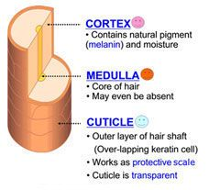
  - Cuticle – transparent outer layer of the hair shaft, made of scales that overlap one another and protect the inner layers of hair.
  - Cortex – largest part of the hair shaft, contains pigment granules (melanin).
  - Medulla – center of the hair shaft, can be a hollow tube, or filled with cells. Some people have no medulla, or it can be fragmented or segmented, continuous, or even doubled.
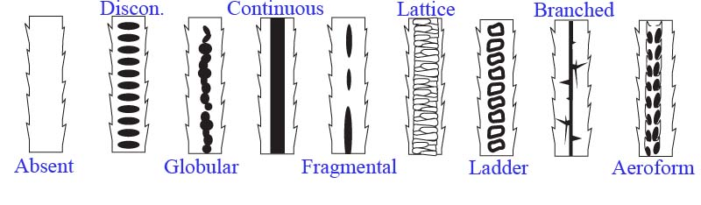
- Explain how you can distinguish between human and nonhuman (animal) hair.
  - Human hair has cuticle scales that are flattened and narrow (imbricate) while animal hair has different types of cuticles, which can be imbricate, coronel, or spinous.
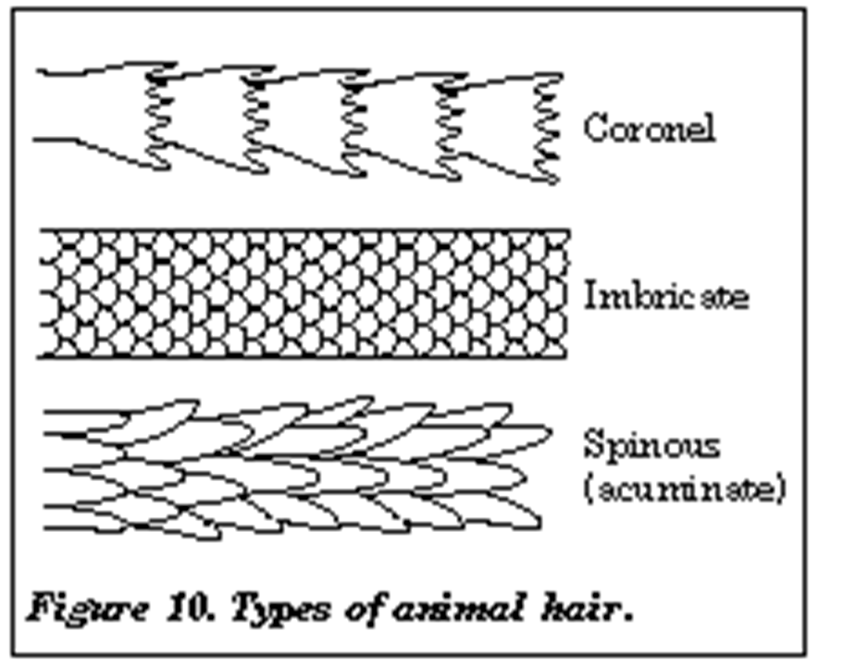
  - The pattern of pigmentation is very different among animals. Pigmentation in humans tends to be denser toward the cuticle, while in animals it is denser toward the medulla. Animal pigments are often found in solid masses called ovoid bodies. Animal hairs can be banded while humans tend to be one color.
  - The medullary index – the ratio of the diameter of the medulla to the diameter of the hair. In humans, it is 0.33 or less and in animals it is 0.50 or more.
- Explain how hair evidence can be used in an investigation.
  - When hair is collected at a crime scene, it is looked at under a microscope and with the eyes. Characteristics looked at are length, color, and curliness. Microscopic characteristics are the patterns of the medulla, pigmentation of the cortex, and types of scales on the cuticle. It is also determined if the hair is dyed or natural.
  - Toxins, poisons, and drugs can be absorbed by the hair shaft and tests are done to identify those substances.
  - If there is a root attached to the hair, DNA can be obtained as well.
- Describe principal characteristics of common fibers and the tests used to identify them.
  - Natural fibers – derived entirely from animal or plant sources.
    - Animal hairs – wool, mohair, cashmere, furs, and silk
    - Plant fibers – cotton, coir, hemp, jute, sisal, and flax
    - Mineral fibers - asbestos, fiberglass
  - Synthetic fibers – derived from natural or synthetic polymers
    - Acetate, acrylic, melamine, nylon, polyester, rayon, and spandex.
  - Tests to identify fibers
    - Microscopic examination
      - Color and diameter match are critical.
    - Chemical composition – numerous tests, all destructive to the fiber
    - Birefringence (refractive differences) – polarized white light is used, nondestructive
    - Infrared absorption – fibers absorb light and vibrate a specific frequencies, nondestructive.
- Distinguish between natural and synthetic fibers and classify some of each.
  - See #11.
- Describe the characteristics of fingerprints.
  - Loops – 65% of the general population
  - Whorls – 30% of the general population
  - Arches – 5% of the general population

  - Fingerprints have ridge characteristics.
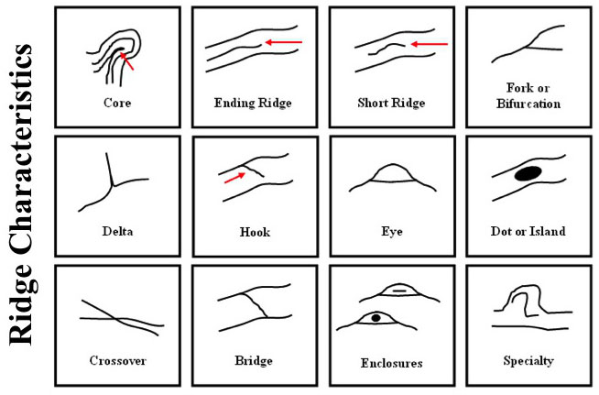
- Identify the basic types of fingerprints.
  - Patent fingerprints – visible prints left on smooth surfaces when blood, ink, or some liquid comes in contact with the hands and is transferred.
  - Plastic fingerprints – actual indentions left in some soft material such as clay, putty, or wax.
  - Latent fingerprints – hidden prints, caused by the transfer of oils and other body secretions onto a surface.

- Explain how fingerprint evidence is collected to include different materials.
  - 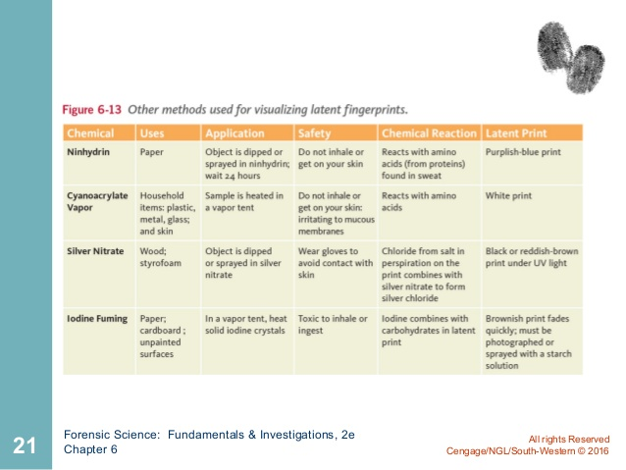
- List some characteristics of glass that distinguishes the different types.
  - Density – mass/volume, each type of glass has a different density
  - Refractive index - submersion method: a piece of glass is placed in liquids of known refractive index. If the piece of glass seems to disappear, it has the same refractive index as the liquid and can be identified.
  - Becke lines – submerge glass in a liquid and observe under a microscope. If the refractive index of the glass is different than the liquid, then Becke lines (a halo-like ring) will appear. If the Becke lines are inside the perimeter of the glass, then the glass has a higher refractive index than the liquid. If the Becke lines are outside the perimeter of the glass, then the glass has a lower refractive index than the liquid.
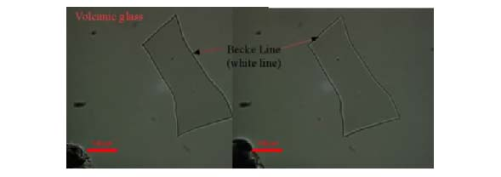
- Explain how refractive index can be used to identify glass.
  - See # 16

- Analyze fracture patterns to determine how glass was broken.
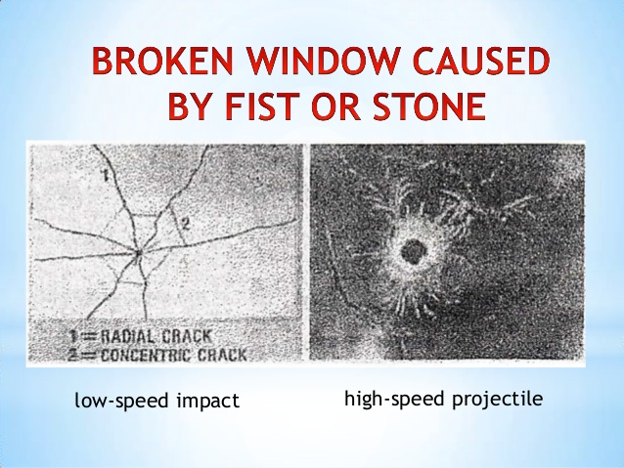
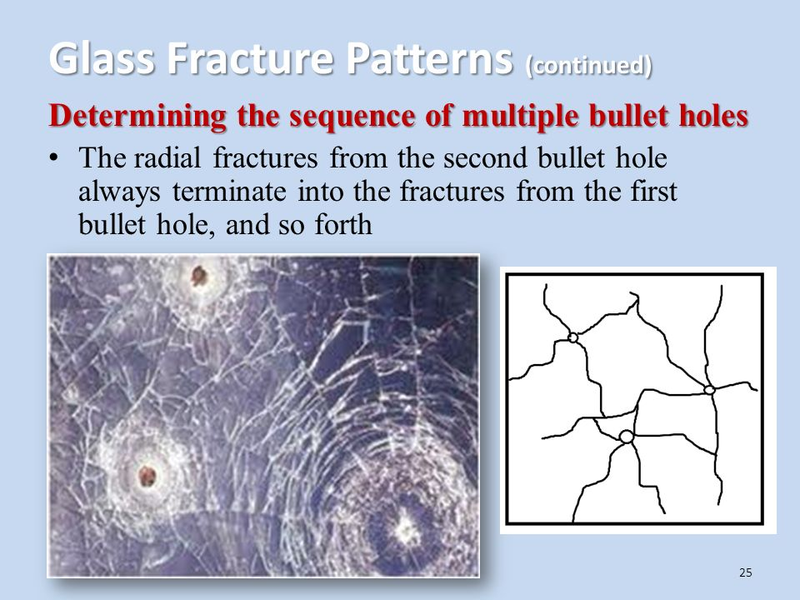
- Recognize various soil types and describe some methods for examining soil samples.
  - Methods for examining soil samples
    - pH
    - low power microscope – reveals plant and animal materials
    - high power microscope – allows id of minerals and rocks.
    - Density gradient

  - Soil Types
  - 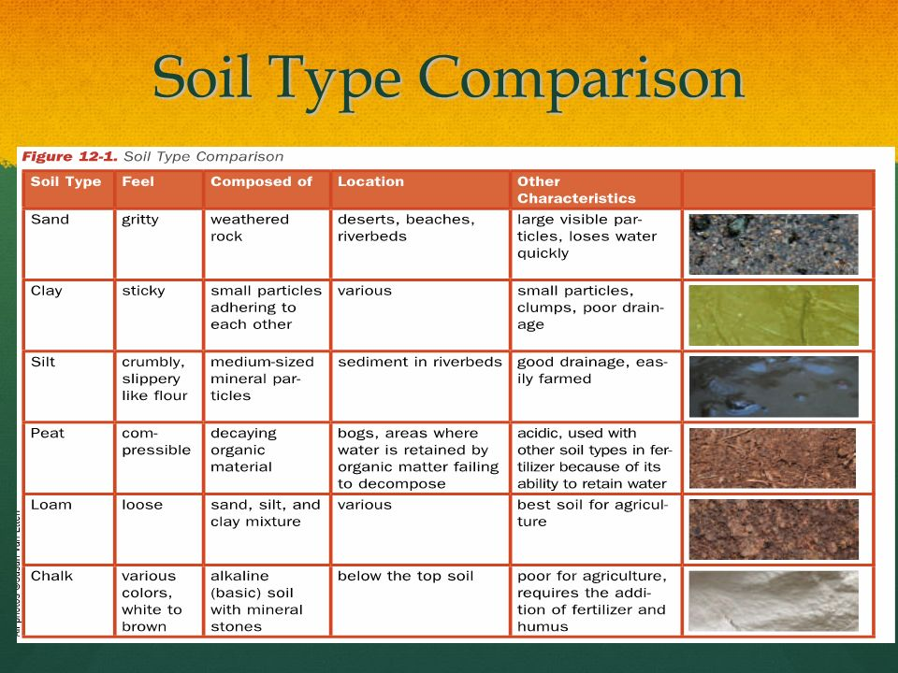
- Distinguish sand samples by size, color and composition.
  - Continental sand – mostly quartz, micas, feldspar, and dark minerals
  - Volcanic sand – dark color, black basalt, green olivine, and volcanic ash
  - Skeletal (biogenic) sand – broken shells, coral, coralline, algae, and sea urchin remains
  - Precipitate sand – calcium carbonate, oolithic, egg-shaped or round sphere’s.
- Explain how soil and sand form.
  - Soil profile

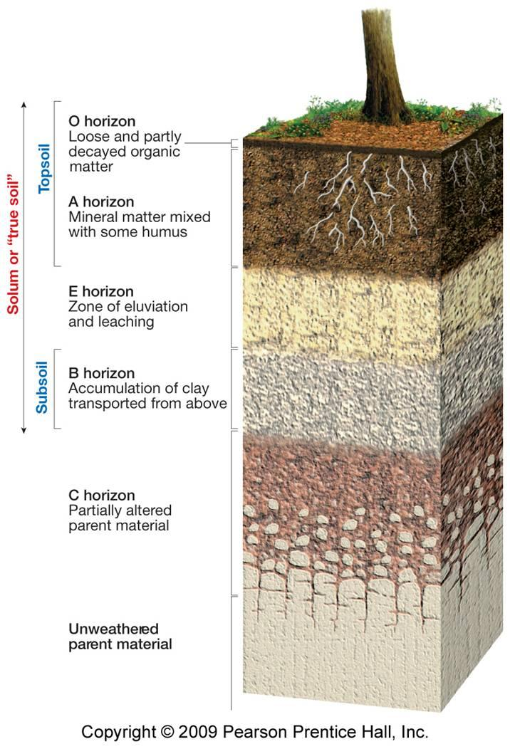

  - Sand is created when water and wind wear down rocks
- Describe 12 types of handwriting exemplars that can be analyzed in a document.
1. Line Quality - Do the letters flow or are they erratic and shaky?
2. Spacing - Are the letters equally spaced or crowded?
3. Size consistency - Is the ratio of height to width consistent?
4. Continuous - Is the writing continuous or does the writer lift the pen?
5. Connecting Letters - Are capitals and lowercase letters connected and continuous?
6. Letters Complete - Are letters completely formed? Or, is a part of the letter missing?
7. Cursive and printed letters - Are there printed letters, cursive letters, or both?
8. Pen Pressure - Is pressure equal when applied to upward and downward strokes?
9. Slant - Left, right, or variable?
10. Line Habits – Is the text on the line, above the line, or below the line?
11. Fancy curls or loops - Are there fancy curls?
12. Placement of crosses on t’s and dots on i’s - Correct or misplaced? Are t’s crossed, crossed in the middle, toward top, or toward the bottom? Are the i’s dotted, dotted toward the right, left, or centered?
Is the text on the line, above the line, or below the line?
- Distinguish between the terms forgery and fraudulence.
  - Forgery – document made, adapted, or falsified with the intention of deceiving someone.
  - Fraudulence – forgery with financial gain
- Describe four features of paper currency that are used to detect counterfeit bills.
  - Portrait stands out form the background & appears raised off the paper.
  - There is minute microprinting on the security threads, as well as around the portrait.
  - Serial number is evenly spaced and the same color as the Treasury seal.
  - Check letter and Quadrant Number.
  - Federal Reserve seal has no sharp points, and the Treasury seal has clear, sharp sawtooth points
  - Clear red and blue fibers are woven throughout the bill. Security thread is evident, consisting of a thin,
embedded vertical line or strip with the denomination of the bill written on it.
  - Federal Reserve Number and Letter
  - Series
  - Check Letter and Face Plate Number
  - Watermark appears on the right side of the portrait of the bill in the light
  - When a new series bill is tilted, the number in the lower right-hand corner makes a color shift from copper to green resulting from color-shifting ink

- Distinguish between the five manners of death.
  - Natural death – interruption or failure of body functions due to old age or disease. Examples are stroke, heart attack, old age, and cancer
  - Accidental death – caused by unplanned events, such as a car accident or falling from a ladder
  - Suicide – a person purposefully kills oneself
  - Homicide – death of one person caused by another
  - Undetermined – cannot determine the manner of death

- Distinguish between cause, manner, and mechanisms of death.
  - Cause – the reason a person dies. Examples are injury, stroke, shooting, bludgeoning, etc.
  - Manner – the way a person dies – see #44
  - Mechanism – the specific change in the body that brought about death. Examples are loss of blood (exsanguination), heart stoppage

- Explain how the development of algor, rigor, and livor mortis occur after death.
  - Livor mortis – “death color”, as a body begins to decompose, blood seeps down through the tissues and settles into the lower parts of the body. Begins 2 hours after death and is permanent after 8 hours.
  - Rigor Mortis – “death stiffness”,
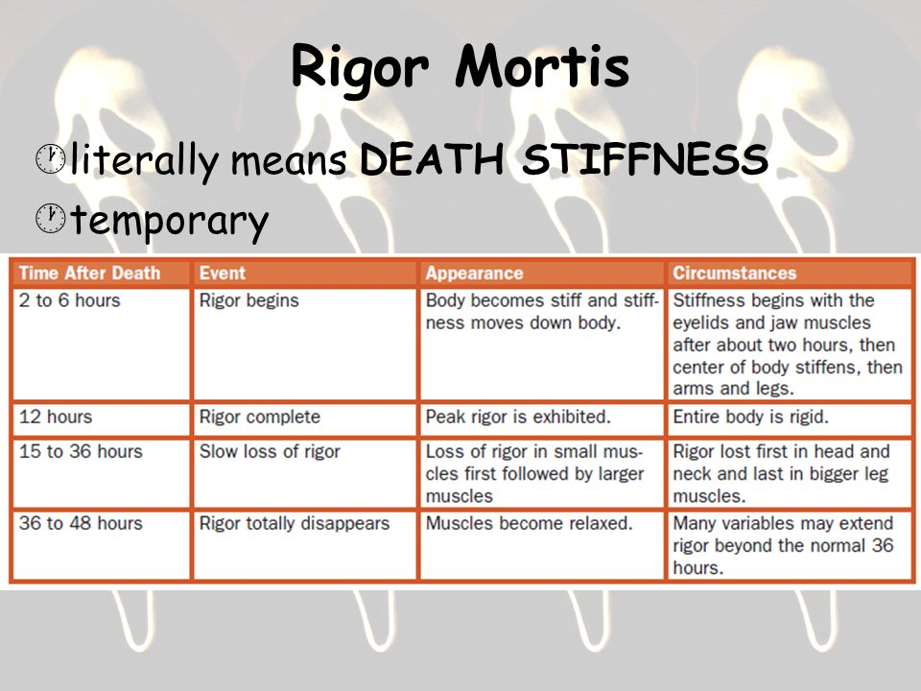
  - Algor Mortis – temperature loss of a corpse.
    - For the first 12 hours, body loses 1.4ºF. After 12 hours, the body loses 0.7ºF every hour until it reaches ambient temperature.

- Use evidence from stomach contents to determine time of death.
  - In general, it takes 6 hours for the stomach to empty its contents into the small intestine and other 12 hours for it to leave the small intestine.
  - It takes about 24 hours for food to be completely eliminated from the large intestine.
- Explain how insect evidence can be used to determine time of death.
  - Within minutes of death, blowflies come to a corpse, attracted by the 1st stages of decomposition and lay eggs. The eggs hatch & feed on the decaying flesh.
  - Tiny wasps then come in and lay their eggs on maggots already present on the body.
  - Wasp larvae live as parasites in the maggots, feeing on their flesh.
  - Cheese skippers arrive after putrefaction is underway, attracted by fluid seepage from the body.
  - Last group to arrive, mites & beetles, feed on dry tissue at the end of decomposition.
- Explain how environmental factors influence the estimated time of death.
  - 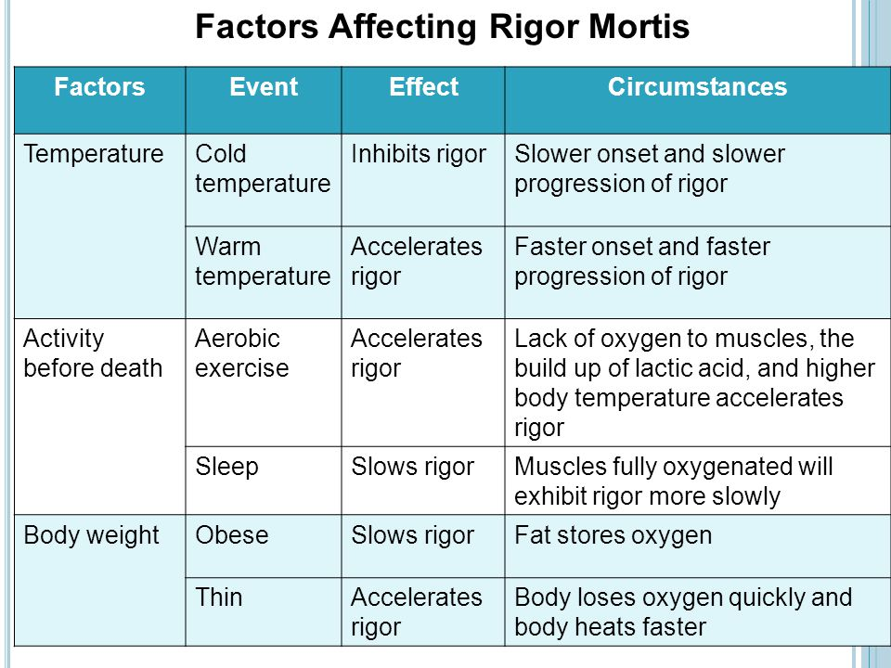
- Describe how bone is formed.
  - Bones originate from living cells called osteoblasts
  - In a fetus, bones begin as soft cartilage – the same material that makes up our ears
  - In a process called, ossification, osteoblasts migrate to the center of the cartilage & deposit minerals (calcium phosphate) that harden to form bone
    - Ossification begins during the first few weeks of pregnancy.
      - By the 8th week, the outline of the skeleton is formed & visible in an x-ray.
      - As bone develops, a protective membrane layer containing nerves & blood vessels (the perisoteum) covers the surface of the bond. It keeps bones moist & aids in repairing injuries to the bone.

- Distinguish between male and female skeletal remains based on skull, jaw, brow ridge, pelvis and femur.
  - Skull
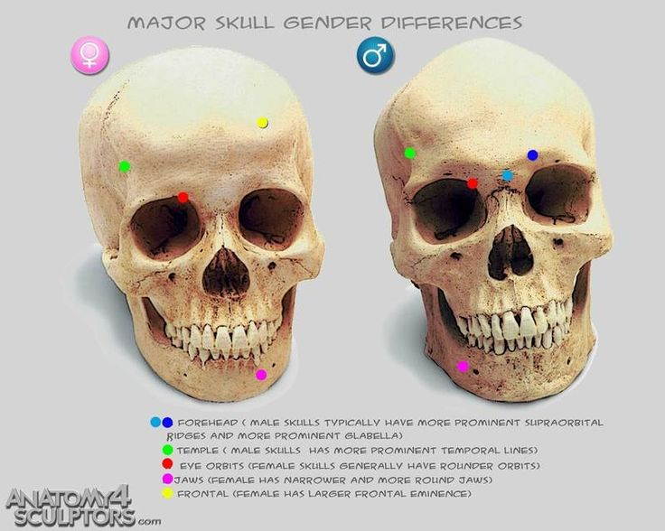
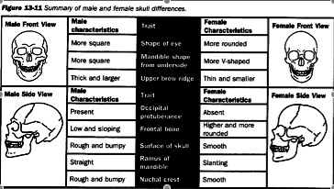
  - Pelvis
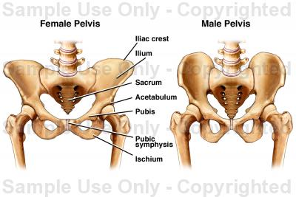
Region | Bone | Female | Male
Pelvis | Subpubic angle | 90° | 50° - 82°
Pelvis | Shape of pubis | Rectang-ular | Triang-ular
Pelvis | Shape of pelvic cavity | Oval | heart
Sacrul | Sacrum | Shorter, broader, curved outward | Longer, narrower, curved outward

  - Femur
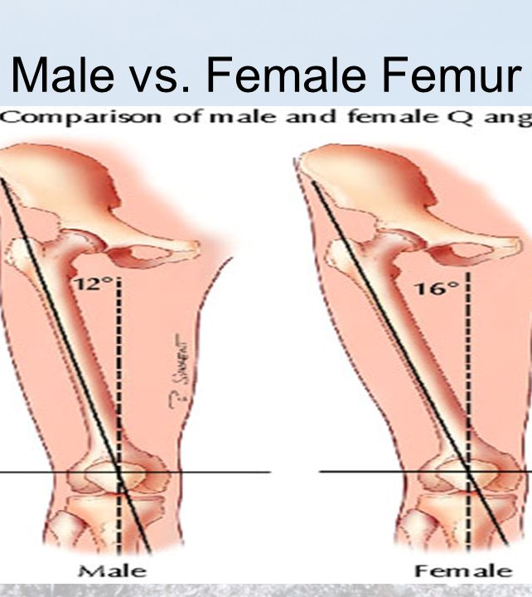
- Describe how bones contain a record of injuries and disease.
  - Healing a broken bone
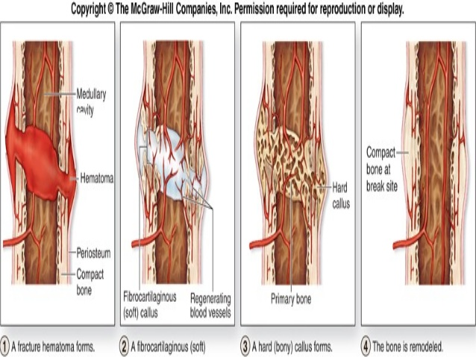
  - Occupational stresses wear on joints
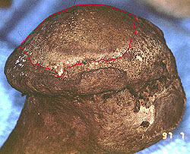
  - Surgeries or healed wounds aid in identification
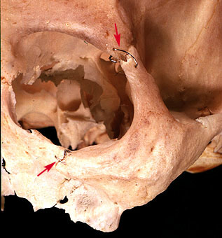
- Describe how a person’s approximate age could be determined by examining his or her bones?
  - 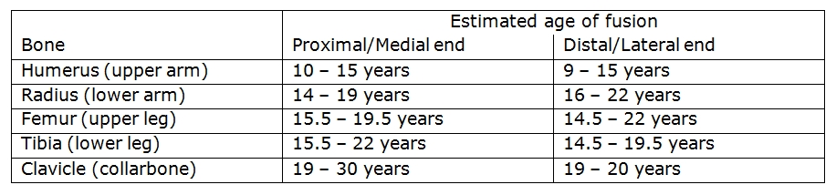
- Explain the differences in facial structure among different races.
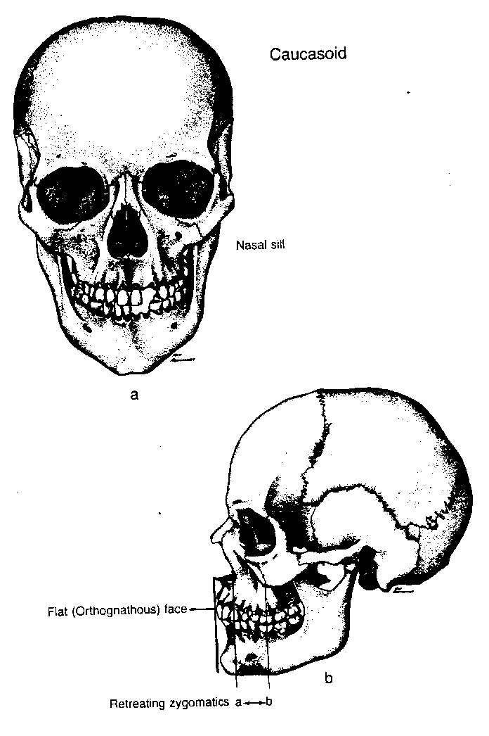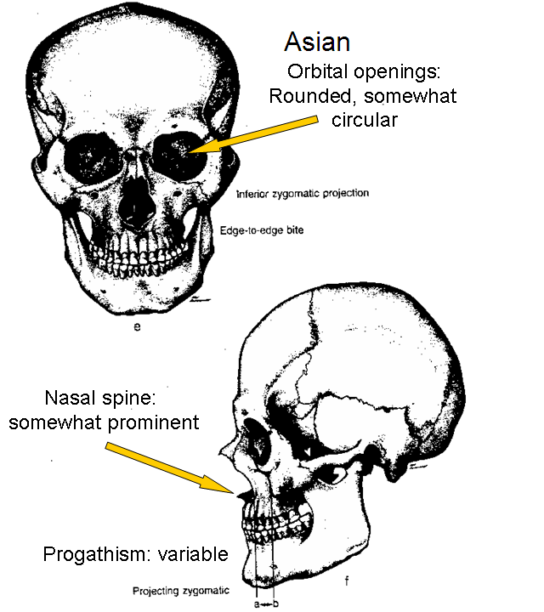
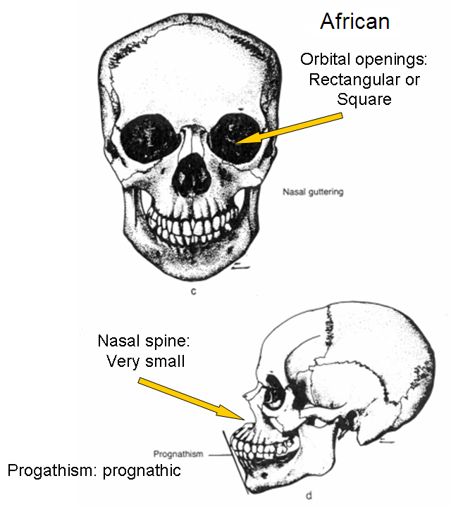
- Describe the role of mitochondrial DNA in bone identification.
  - Bones contain mitochondrial DNA, this is DNA that is inherited only from one’s mother. Mitochonrial DNA can be extracted and profiled from bones long after nuclear DNA has degenerated. As long as there is DNA from the mother’s side of the family, a match can be made.

- Identify the five types of controlled substances.
  - Narcotics - analgesic or pain-killing substance that depresses vital body functions such as blood pressure, pulse rate, and breathing rate. The regular administration of narcotics will produce physical dependence.
  - Hallucinogens - a substance that induces changes in mood, attitude, thought, or perception. The most common hallucinogen is marijuana.
  - Depressants - a substance used to depress the functions of the central nervous system. Depressants calm irritability and anxiety and may induce sleep. Alcohol is the most widely used and abused drug.
  - Barbiturates - commonly referred to as “downers” because they relax, reacte a feeling of well-being, and produce sleep.
  - Stimulants - a substance taken to increase alertness or activity.
- Describe the role of various types of toxins in causing death.
  - Bacterial toxins – such as tetanus (causes violent muscle spasms) and botulism (irreversible damage to nerve endings, most poisonous biological substance)
  - Pesticides and heavy metals – used to protect crops, can be poisonous and deadly if consumed
  - Bioterrorism agents – ricin (poisonous protein found in castor beans, very deadly), anthrax (deadly if absorbed by skin or inhaled), and sarin (most toxic and rapid acting)
- Discuss agents that may be used in bioterrorism.
  - See #26
- Explain how crime-scene evidence is collected and processed for DNA evidence.
  - Collecting DNA evidence
    - Use disposable gloves and collection instruments.
    - Avoid physical contact, talking, sneezing, and coughing in the evidence area.
    - Air-dry evidence and put it into new paper bags or envelopes.
    - If evidence cannot be dried, freeze it.
    - Keep evidence cool and dry during transportation and storage.
  - Preparing DNA evidence
    - DNA is mixed with special enzymes.
    - The enzymes cut apart the DNA in specific places forming different sized fragments.
    - The DNA is loaded into the chambers found on an agarose gel.
    - An electric current is passed through the gel separating the fragments by size.

- Explain how DNA evidence is compared for matching including both inheritance and
criminal matches.
  - For inheritance – the DNA sample must match half of the parent’s DNA.
  - For criminal match – the DNA sample must match the crime scene or suspect sample exactly.
- Explain the composition and function of blood cells.
  - Platelets aid in clotting blood and repairing damaged blood vessels
  - White blood cells – fight disease and foreign invaders (viruses and germs), only blood cells to contain DNA
  - Red blood cells – carry oxygen and carbon dioxide through out your body. Contain antigens, a protein that tells your body to produce antibodies
- Describe how to determine the blood type of a sample of blood.
  - Blood typing
Blood Type | Antigens on red blood cell | Antibodies in serum | % of US population
A | A protein | anti -B | 42
B | B protein | anti - A | 12
AB | both A & B protein | none | 3
O | none | both anti -A & anti - B | 43

  - Rhesus factor (Rh factor)
    - 85% of people have the Rh factor: Rh +
    - 15% of people do NOT have the Rh factor: Rh –

- Explain how to determine area of convergence.
  - Draw lines down the long axis of the blood spatter and note where the lines intersect.
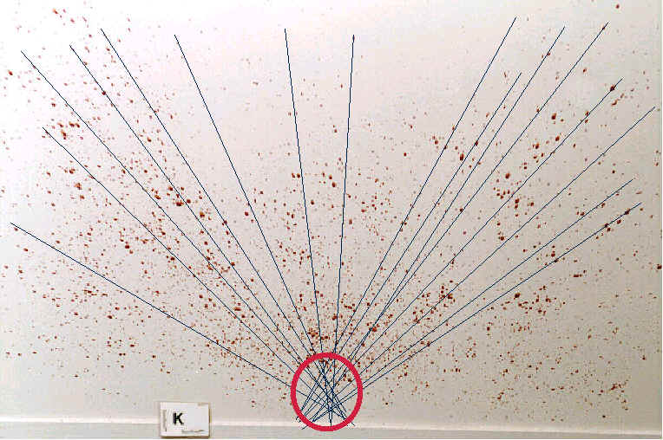
- Calculate point of origin of a blood drop.
  - See #32
- Distinguish between a bullet and a cartridge.
  - Bullet – a projectile that is released when a firearm is discharged
  - Cartridge – a case that holds a bullet, primer powder, and gunpowder.
- What is rifling and how does it affect projectile flight?
  - The spiral pattern of lands and grooves in the barrel of a gun. It causes the bullet to leave the gun barrel in a spiral .
- Explain how bullets are test-fired and matched.
  - Bullets are test fired into water tanks. The spent bullets and casings are then matched to those from the crime scene under a microscope. They must match exactly.
- Explain the relationship between barrel size and caliber.
  - The diameter inside the barrel is the caliber. It is usually measured in hundredths of an inch (.22, .357, .44) or in millimeters (9mm)
- Determine the position of a shooter based on bullet trajectory.
  - To calculate the height of the shooter:
    - Height of gun = height above horizon + distance from horizon to ground
    - Height above horizon = distance to shooter × tan angle.
- Compare and contrast oxidation and combustion.
  - Oxidation - The combination of oxygen with other substances to produce new substances.
  - Combustion - the rapid combination of oxygen with another substance accompanied by the production of noticeable heat and light.
- What are the three requirements to start and sustain a fire?
  - A fuel must be present
  - Oxygen must be available in sufficient amounts
  - Heat must be applied.
- What is the difference between a high explosive and a low explosive?
  - Low explosives have a velocity of detonation below 1000 meters per second.
  - High explosives have a velocity of detonation above 1000 meters per second.
- What is the difference between primary and secondary explosives?
  - Primary explosives are easily detonated by heat or shock, usually used to detonate other explosives through a chain reaction and called primers. Examples are blasting caps, nitroglycerin
  - Secondary explosives are relatively insensitive to heat, shock, or friction and normally burn rather than detonate if ignited in small quantities in an open area. Examples are dynamite, TNT, PETN, and RDX
- What is the most common container for collecting fire evidence and at what locations should it be collected?
  - Unused paint cans with lids are the most common container for collecting fire evidence. It should be collected at the source and at measured distances away from the source.

