Determining the Age of a Skull Name______________________
Directions: Answer the following on a separate sheet of paper.
Part A:
Using the figures below showing the relationship between age and skull sutures, determine the approximate age of a skull with the following features:
- Lambdoidal and sagittal sutures fused. Age __________
Coronal sutures not fused.
- Lambdoidal sutures almost fused. Age__________
Sagittal and coronal sutures not fused.
- All sutures fused. Age__________
- Lambdoidal wide open. Age__________
Sagittal and coronal sutures open.
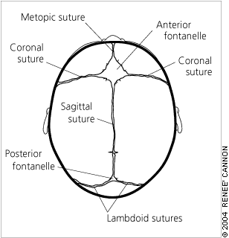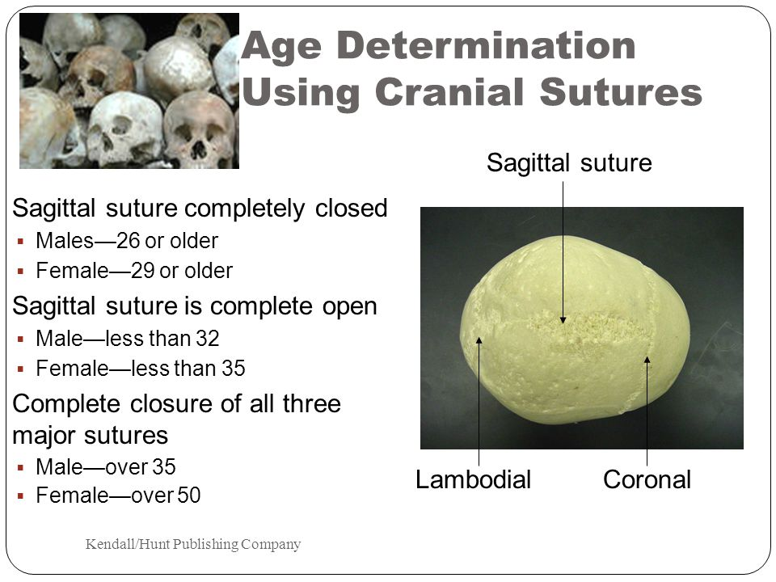

BONES: MALE OR FEMALE?
Directions: Read the following descriptions to determine if they are consistent with a male or female using the information from the Anthropology Practice worksheet to complete.
Case #1 ______________________
Round eye orbits, subpubic angle of 103 degrees, rectangular-shaped pubis, smooth skull. Explain your answer.

Case #2 ______________________
Pelvis narrow, protuberance on occipital bone, sloping forehead. Explain your answer.

Case #3 ______________________
The skull was found to be smooth with small brow ridges; would you expect to find a subpubic angle larger or smaller than 90 degrees? Explain your answer.

Case #4______________________
A long, narrow sacrum with triangular pubis; would you expect to find the subpubic angle larger or smaller than 90 degrees? Explain your answer.

