Unit 3:
Drugs & Toxicology, Blood & Spatter, and DNA Study Guide
Name_____________________
- List the five types of controlled substances and how they generally affect people.
  - Narcotics – analgesics, pain killers – depress vital body functions such as heart rate, breathing rate, and blood pressure, Ex. opium, morphine, cocaine
  - Hallucinogens – induces changes in mood, attitude, thought, or perception, Ex. marijuana, pcp
  - Depressants – depressed the functions of the central nervous system, calm irritability and anxiety, induce sleep. Ex. Alcohol, barbituates
  - Stimulants – increases the functions of the central nervous system, increase alertness and activity, Ex. Methamphetamines, ice, ecstasy
  - Steroids – increase secondary male sex charateristics, increase anger and irritability, decrease sex drive, ex. Testosterone

- List the three ways people can be exposed to drugs.
  - Intentionally – by treating illness or relieving pain
  - Accidentally – by harmful combinations or overdoes
  - Deliberately.- by harming or killings others or committing suicide

- Describe at least two other substances that can be considered to be a toxin.
  - Bacterial toxins, such as anthrax and ricin
  - Heavy Metals, such as mercury and lead

- Compare presumptive vs confirmation tests
  - Presumptive tests give a police officer a reason to hold you for further testing to confirm you are on a certain drug or under the influence of alcohol, Ex Horizontal gaze. Nystagmus, walk and turn, or one leg stand.
  - A confirmation test is given by a doctor or lab technician to determine exactly which particular drug someone has ingested.

- BAC – meaning? Blood Alcohol Concentration Legal limits? 0.08%

- What is a field sobriety test and how is it performed?
  - See the answer to #4a.

- What is the composition of blood and what do they do? (four major parts)
  - Red blood cells (erythrocytes) – most abundant in the body, produced in bone marrow, carry a protein called hemoglodin that carries oxygen to our cells
  - White blood cells (leukocytes) – part of the immune system and destroy infectious agents
  - Plasma – yellowish liquid that contains electrolytes, nutrients, hormones, and clotting factors
  - Platelets (thrombocytes) – clotting factors the help seal a wound and prevent blood loss.

- Describe an antigen-antibody reaction and explain how an antibody identifies the antigen.
  - Blood cells can contain antigens on their outside, either A, B, AB, or no antigens. There are also antibodies in your blood that will attack the incorrect antigen and cause agglutaination (clumping) if the wrong blood types is given to you. For example, if you have type B blood, then you have anti-A antibodies in your blood. If you are mistakenly given type A blood, then the anti-A antibodies attack the A antigens on the new blood and cause clumping. This could kill you.

- Describe how to determine someone’s blood type.
  - They take some of your blood to determine if it agglutinates (clumps) when given the anti-A, anti-B, and anti-Rh antibodies. For example, if your blood sample clumps in anti A and anti-Rh, you have A+ blood. If it does not clump in anti-A or anti-B but does in anti-Rh, you have type O+ blood.

- Explain why blood types provide class evidence and not individual evidence.
  - Many people can have the same type of blood and it cannot be proven to belong to a specific individual.

- Distinguish between spikes and satellites on blood spatter.
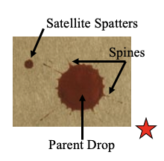
- Distinguish between blood spatter based upon blood dropping onto a smooth surface and a rough or textured surface.
  - Blood dropped on a smooth surface will have less spikes than one dropped on a rough surface.

- Describe the six types of blood spatter (not in your notes but on powerpoint!!).
  - 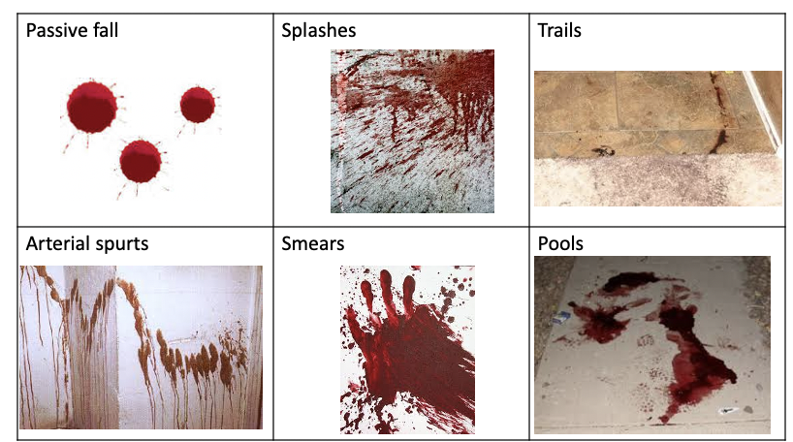

- Explain how to draw lines of convergence from several drops of blood in order to determine the area of convergence.
  - 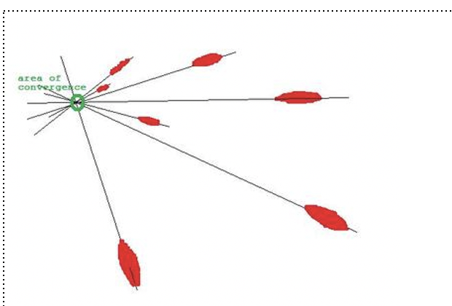

- Describe how to determine the height of the source of blood known as point of origin using the tangent law.
  - First determine the angle of the blood drop: angle = sin⁻¹(width/length) – without the tail
  - Draw the lines of convergence.
  - Measure the distance from the front of the blood drop to the center of the area of convergence.
  - To determine the height = distance x tan angle

- Describe the structure of a DNA molecule (nuclear).
  - 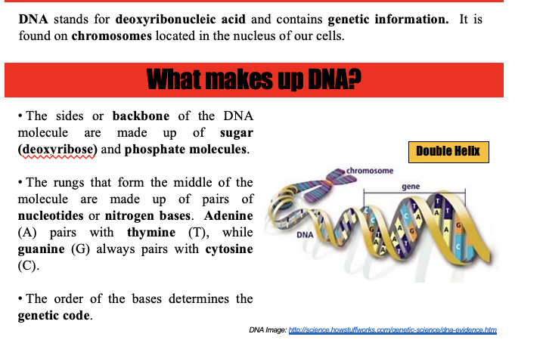

- Explain why DNA evidence is considered to be individual evidence.
  - DNA is unique to every single individual; on the planet, except identical twins.

- Compare VNTR and STR strands with regard to size and number of base pairs.
  - VNTRs are strands of DNA at least 80 base pairs long,. They used to be used for DNA profiling/fingerprinting but can be easily degraded and you would need quite of bit of a sample to create the profile.
  - STRs are much shorter, maybe 13 base pairs longs. Can use smaller sample sizes and they do not degrade as quickly.

- Explain the role of DNA fingerprints in:
  - tissue matching – To match tissue found at a crime scene to a suspect or a victim, the DNA must match close to 100%.
  - inheritance matching – To determine a familial relation, the DNA must match at most 50%.

- Discuss the advantage of using mitochondrial DNA (mtDNA) instead of nuclear DNA in an attempt to identify the remains of an individual.
  - Mitchondrial DNA is found in the mitochondria of all cells and is plentiful while nuclear DNA is only found in the nucleus of cells is not as plentiful. Mitochondrial DNA also only comes from you mom, while nuclear DNA comes from both parents.

