1. Solve the Mystery!
Mrs. Brown had baked a birthday cake for her husband and then left it in a tin on the kitchen table. When she returned from shopping all that was left in the cake tin was a few crumbs and a smudge of blood where the thief had snagged their finger on the sharp edge of the tin. Below are the DNA fingerprints of her four children. Which one of the children’s DNA fingerprints most closely matches the blood stain and therefore is most likely to be the thief?

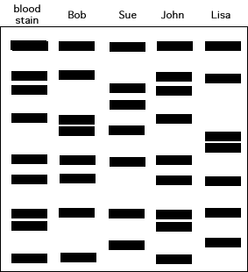

2. Identify the body
A soldier has been killed in an explosion and has lost his dog tags that identify him. Three soldiers are missing from their unit so the Army ask the three sets of parents for a DNA sample so they might compare it to the soldier’s DNA and therefore make an identification.
Which set of parents is the soldier the son of?

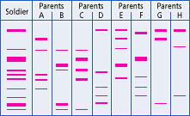

3. Identify the father
Look carefully at the DNA fingerprints below and decide which of the men (P, Q or R) are most likely to be the father.

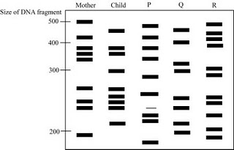

4. Which Pharaoh came first?
A pharaoh’s tomb contains his body, that of his queen, and those of two grown children and their families. Nearby is another tomb of a lone pharaoh. Because of a ancient grave robbers, both tombs, were defaced, erasing which pharaoh came first. Using the following DNA fingerprints, determine the order of these two pharaohs. This is a "maternity test": is the Queen the mother of the lone pharaoh or not? If she is, then the lone pharaoh ascended the throne after his father, the queen's husband. If she is not the lone pharaoh’s mother, then he must be the father of the queen's husband. The fingerprints of the two children are superfluous.

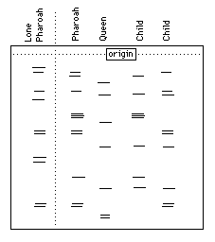

5. Who committed the crime?
A grocery shop has been robbed. The police suspected one of two local criminals may have been responsible, so they brought them in to get a DNA sample to compare against hairs found at the scene of the crime. They also took a DNA sample from the owner of the shop in order to exclude him from their inquiries. So, who committed the crime?

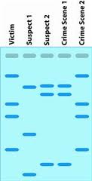

6. Switched at Birth!
Unfortunately, three babies have got muddled up in the Maternity Ward at Torbay hospital.
Can you analyze the results of a DNA fingerprint conducted on three babies and three sets of parents to determine which baby belongs to which parent?

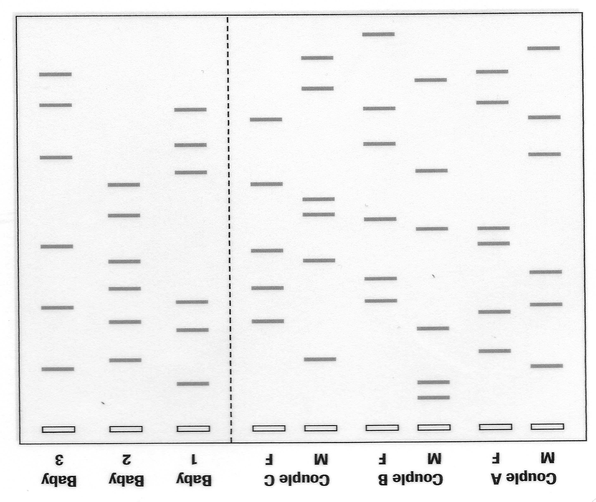

Name:
DNA Mysteries
Directions: Answer each question and explain why you chose each answer.

- Who ate the cake?

- Who were the parents of the soldier?

- Who was the father of the child?

- Which Pharaoh came first?

- Who committed the crime?

- Baby 1 belongs to Couple
Baby 2 belongs to Couple
Baby 3 belongs to Couple

