H Forensic Science
Unit 2A Study Guide

Fingerprints
- What is the difference between direct and circumstantial evidence?
- Which layer of the skin creates fingerprints?
- When do fingerprints form on a person?
- Is there any case in which two people can have the exact same fingerprint? Explain.
- Can a person permanently alter their fingerprints? Why or why not?
- Are fingerprints individual or class evidence?
- What is the 1st principle of fingerprints?
- What is the 2nd principle of fingerprints?
- What is the 3rd principle of fingerprints?
- What are the 3 types of fingerprints? Which is most common and which is least common?
- How can you tell the 3 types of fingerprints apart?
- What are fingerprint minutiae?
- How do you perform a ridge count?
- Determine the type of fingerprints and identify 12 minutiae on each print. Do a ridge count on the first print.

  - 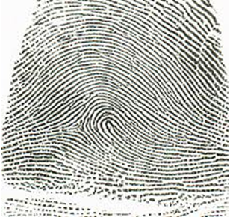
  - 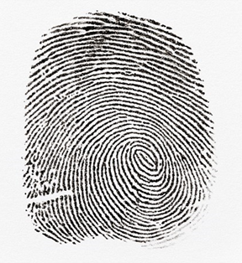
- Determine if these prints match by matching 12 minutiae and completing a ridge count on both.
  - 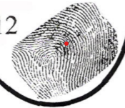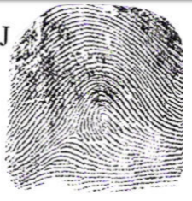
- What is AFIS?
- Describe the 3 types of fingerprints that can be left at a crime scene.
- What methods can be used to visualize latent prints? Which method is the preferred method used by investigators?
- Is fingerprint matching a perfect method to identify a person? Why or why not?
Hair
- What is hair made of?
- How does hair grow? Describe the 3 stages of hair growth.
- Describe the 3 parts of a hair strand.
- What is a medullary index and how is it used to distinguish between human and animal hair?
- What is a follicular tag and why is it useful to investigators?
- Is hair individual or class evidence? Explain.
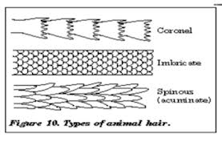
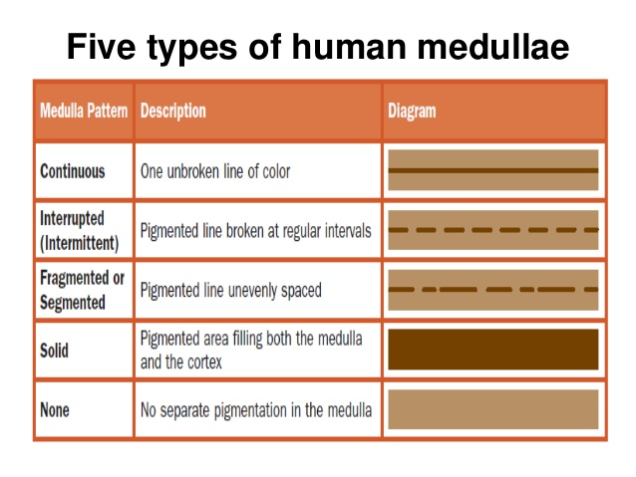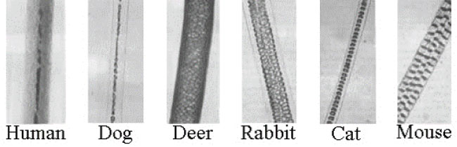

- Use the pictures above to answer the questions.

  - Are these hairs from the same head? Why or why not? 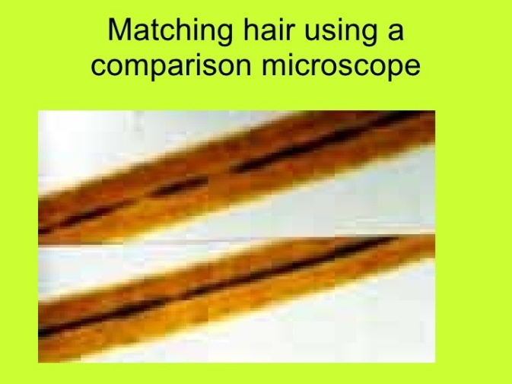
  - Is these hairs from a human or an animal? How can you tell? 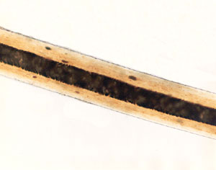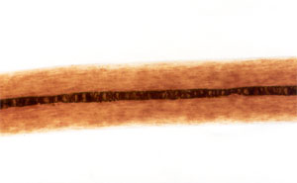

  - What types of cuticle are these and what does that tell you about the hair?
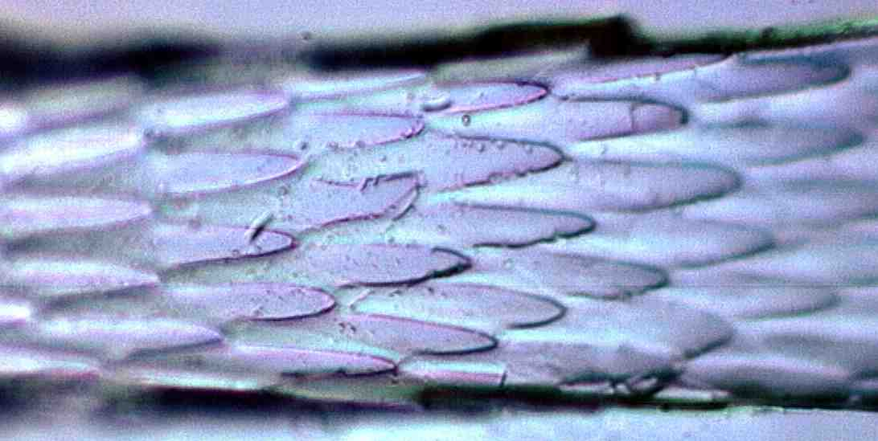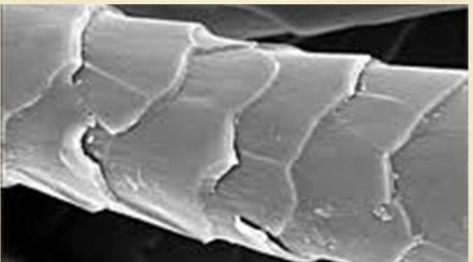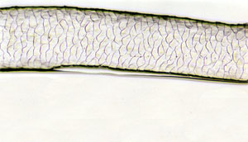
Fibers
- What distinguishes a fiber as natural? Where do natural fibers originate from? Give 2 examples of each.
- What distinguishes a fiber as synthetic? Give examples.
- What two main characteristics would an investigator look for in matching fibers under a microscope?
- How do investigators use a burn chart when completing a burn analysis on fibers?
- Use the burn chart to determine the identity of the fibers described below.
  - This fiber is self-extinguishing, and it chars with the smell of burning hair. It has an open, lace-like ash.
  - This fiber is not self-extinguishing, and it melts with the earthy smell of turmeric and a soft, black irregular ash.
  - This fiber is not self-extinguishing and chars with the smell of burning grass and a soft gray ash.
  - This fiber is self-extinguishing and melts with the odor of burning asphalt and a hard, tan bead.

