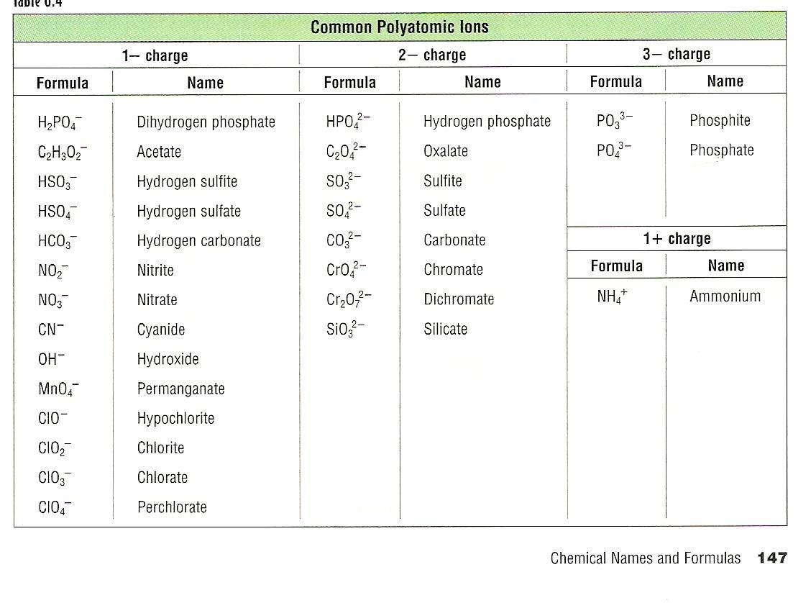

O22-  Peroxide

Hg22+ Mercury (I)