Spring 2019 Honors Forensic Science Final Exam Study Guide

- Define forensic science.
- What is Locard’s exchange principle and give an example.
- What was the ruling in the court case of Frey v. United States in terms of evidence allowed in court?
- What was the ruling in Daubert v.Merrill Dow in terms of evidence allowed in court?
- What are the Federal rules of evidence?
- Distinguish between class and individual evidence and give 2 examples of each.
- What is trace evidence?
- Who is the first person to arrive at a crime scene and what is their role?
- What is a standard reference sample?
- Define the following types of fingerprints and give an example of each.
  - Plastic fingerprint
  - Patent fingerprint
  - Latent fingerprint
- Describe 4 methods used to develop latent prints at a crime scene.
- What are the 3 kinds of fingerprints a person may have and how are they distinguished from each other?
- What are fingerprint minutiae?
- How do you complete a ridge count on a fingerprint?
- What type of fingerprints are these and circle and label 7 different minutiae on each print?
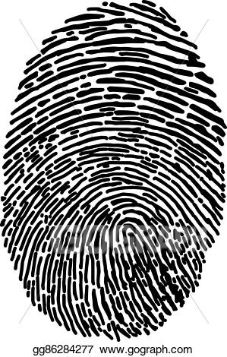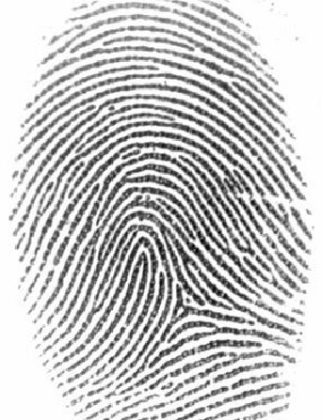

- Describe the 3 stages of hair growth and how long each stage lasts.
- What are the 3 parts of a hair’s structure? Where are the pigment granules in a hair found?
- Describe the 3 types of cuticles that exist in a hair. What type do humans have?
- What is the medullary index and how is it used to distinguish human from animal hair?
- What percentage of fiber evidence is lost from a crime scene within 24 hours?
- What are the 2 main types of fibers? Give 3 examples of each
- Describe the ways a forensic scientist determines what a fiber is made of.
- When questioning the author or authenticity of a document, what is an exemplar?
- What is forgery? What is fraudulence?
- How can a criminal make a forged document look older than it really is?
- What are 12 handwriting characteristics to look for when judging if someone forged a document?
- Describe the differences between regular, soda-lime glass, tempered glass, laminated glass, and bullet proof glass.
- Explain how glass fractures. Use the terms concentric and radial fractures, include which occur first and second and on which side of the glass each occur.
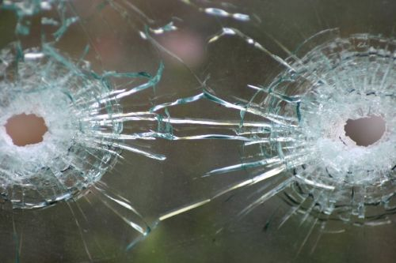
- Which bullet hole occurred first? Explain how you determined your answer.
- What is refractive index and how is it used to determine the type of glass?
- What does it mean when a soil sample changes color?
- Describe 4 methods forensic scientists use in test soil.
  - Visual
  - Density
  - Microscopic
  - pH
- How many bones does an adult human have? A baby?
- Describe the differences between male and female skulls.
- How can a femur be used to determine the approximate age of a victim?
- Describe each of the stages of decomposition.
- How would each factor below affect decomposition?
  - Hot weather
  - Cold weather
  - Found in a freezer
  - Found in a lake
  - Wrapped in a blanket
  - Found without clothes
- Describe livor mortis, including its timeline.
- Describe rigor mortis, including its timeline.
- Describe algor mortis and how it is used to determine the time of death of a victim.
- Explain how each factor below would affect algor mortis.
  - Hot weather
  - Cold weather
  - Being very thin
  - Exercising right before death
  - Found without clothes on
  - Being wrapped in blankets
- A woman was found at 6am on Wednesday, May 1st with a liver temperature of 29.3°C. How long ago did she die?
- An elderly man was found decesased in his apartment just after noon today with a liver temperature of 22.2°C. How long ago did he die?
- What is manner, cause, and mechanism of death? Give examples of each.
- Describe these types of drugs: narcotics, stimulants, depressants, hallucinogens, club drugs, and anabolic steroids. Give some basic effects for each one and at least one example of each.
- What is meant by physical dependence? What is meant by psychological dependence?
- What is the Controlled Substances Act. Describe each schedule of drug within the act.
- How does alcohol spread throughout the body once consumed? What affects how quickly a person feels alcohol’s effects?
- What is the legal limit for alcohol?
- Describe 2 field sobriety tests and why are they used?
- What are the different blood types people have?
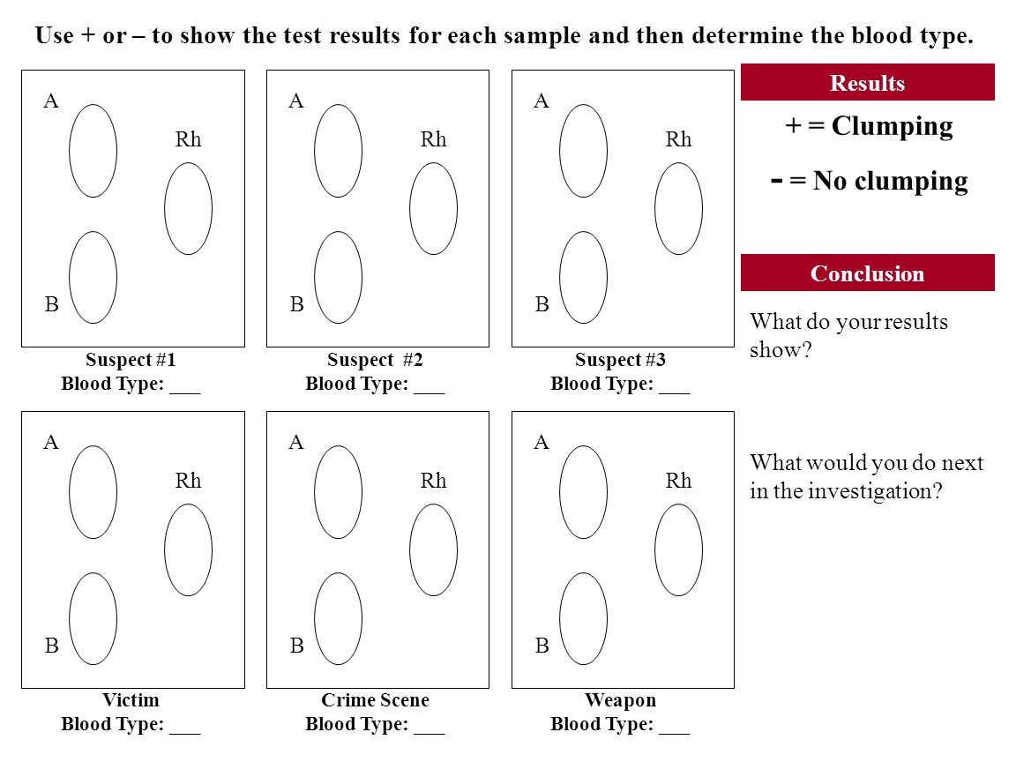

- Which of these images came from low velocity spatter, high velocity spatter, and medium velocity spatter? How can you tell?
- What is passive spatter?
- What direction was the blood travelling in the picture below?
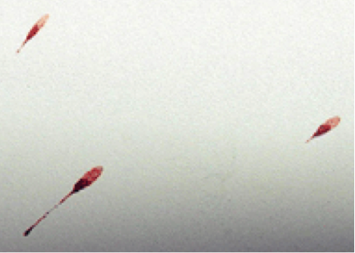

- How do you determine the point of origin and the height that the blood spatter originated from?
- What is a DNA fingerprint?
- What is CODIS?
- What is the difference between RFLP and STR?
- What is a restriction enzyme and what does it do?
- The DNA fingerprints were made from blood samples taken from a puppy and four possible sires in an effort to determine the puppy’s pedigree. According to this information, which sire is probably the father of this puppy?YOUR ANSWER.

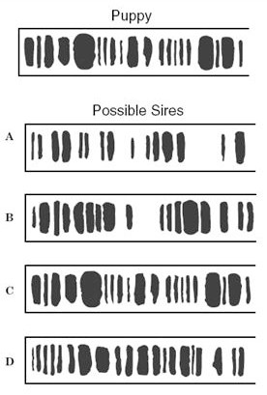

- Suzy was assaulted and is a victim of rape. The police collect a sample of sperm that was left at the crime scene and now have 3 possible suspects. Which of the suspects committed the crime?
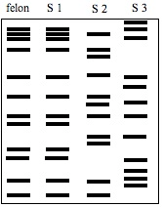
- What is ballistics?
- What are lands and grooves on a gun?
- What is rifling and why is it important for forensics?
- What does caliber of a bullet mean?
- What is the proper method to swab a suspect for gunshot residue, or GSR?
- What is the difference between skid marks, tire scrub, and yaw marks made by tires on a surface?
- How are tool marks cast?
- Why don’t forensic scientists use the orginal tool mark, why do they take casts?

