KEY Hair, Fibers and Fingerprint Review
1. What remains the hair’s most characteristic forensic feature?
The color of the fair is the most characteristic forensic feature.

2. Describe the 3 parts of hair?
a. Cuticle – outer covering of hair consisiting of scales that come in 3 shapes: imbricate, coronel, and spinous.
b. Cortex – inside the cuticle, contains the pigment granules that color hair.
c. Medulla – the inner core of a hair shaft. There are 5 types of medulla in a human hair. You can identify a hair as human or animal based on the size of the medulla

3. The cortex contains granules. What are these granules and what do they determine?
Pigment granules color hair

4. What does the medullary index measure? What is one difference between the medullae of human and animal hairs?
Medullary index measures the diameter of the medulla vs. the diameter of the hair shaft. If the quotient is 0.33 or lower, the hair is human. If the quotient is 0.50 or larger, the hair is animal hair.

5. Name, describe, and sketch the five human medulla patterns.
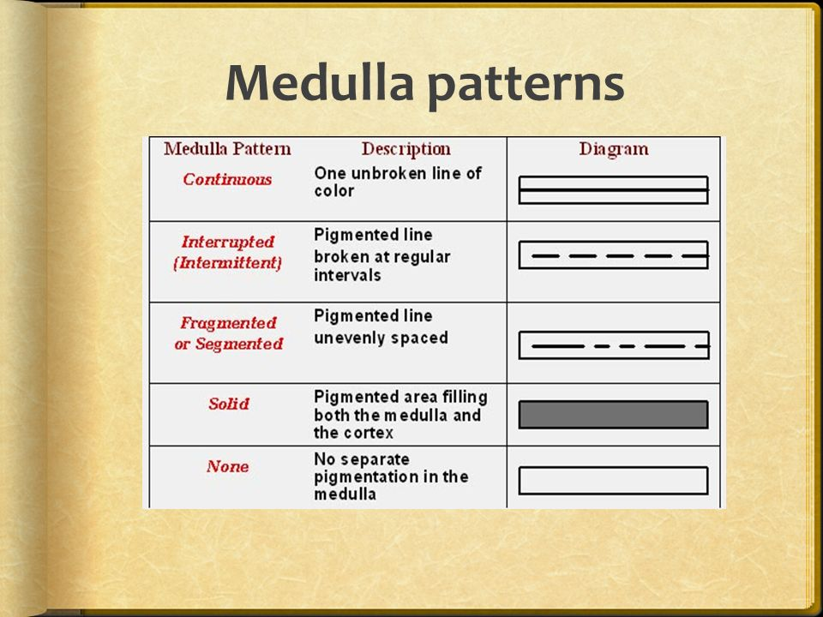
6. What are the three primary cuticle patterns? Which one is found on human hair?
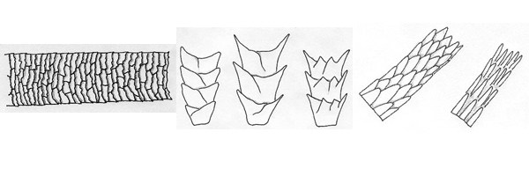
Left: Imbricate (human) Middle: Coronel Right: Spinous
7. What is the main purpose for examining a hair found at the crime scene?
To determine if a person was present at the crime scene or can be eliminated as a suspect at a crime scene.

8. Can you distinguish a hair that has been bleached or dyed from a natural hair? How or why not?
A hair that has been dyed or artificially colored, displays a smooth uniform color similar to tinted glass. In contrast, naturally-colored hair usually contains granules with a texture similar to picture colored by a crayon.

9. Can the following be determined? Why or why not? If so, how?
a. Body area of a hair. Yes, head hair tends to have a smaller diameter than pubic hair
b. Racial origin of a hair. Sometimes, people of Asian descent tend to have solid medullas in their hair shaft.
c. Age and sex of a hair. No.

10. Is it possible to determine if a body hair so was forcibly removed from the body? Why or why not? If so, how?
Yes maybe, by the presence of a follicular tag.
11. DNA can be extracted from hair so why is hair found at a crime scene not normally used for DNA typing?
It is mitochondrial DNA which is only inherited from the mother.
12. Name the three phases of hair growth. A criminalist is more likely to collect DNA from hairs in which stage of growth? Why?
Anagen: active growth phase, lasts 3 – 5 years. A criminalist is most likely to collect DNA from this stage because it can be removed with a follicular tag, which has nuclear DNA in it.

Catagen: transition phase, lasts about 12 weeks while the hair detaches from the follicle.

Telogen: resting phase where the hair falls out, lasts 1 – 2 weeks.

13. What is a standard/reference hair? Why must questioned hairs and standard/reference hairs being compared come from the same area of the body? How many standard reference hairs are taken from a person’s head?
A standard/reference hair is a hair that is intentionally removed from a victim or suspect to use as a comparison to a hair found at a crime scene. The hair must come from the same area of the body as the hair it is being compared to because hairs from different parts of the body a re different. You need about 50 standard/reference hairs from a person’s head and 24 from the pubic area.

14. Can you distinguish between natural and synthetic fibers? If so, how?
Yes, Microscopic examination and burn analysi can distinguish natural and synthetic fibers

15. What is the difference between a natural fiber and a synthetic fiber?
Natural fibers are wholly derived from plants, animals, or minerals.

Synthetic fibers are derived from a combination of natural and man-made materials or whooly man-made materials.

16. What are some tests used to identify fibers? What are the pros and cons of each test?

17. Name two physical characteristics that frequently are used to identify fibers.
Color, striations, diameter, cross-sectional shape of the fiber

18. What is the first fundamental principle of fingerprints?
No two fingerprints have the same, identical ridge characteristics.

19. What are ridge characteristics? What is another name for ridge characteristics?
Minutiae or ridge characteristics, are ridges or folds in the skin of hands and feet that are unique to each individual.

20. What is the second fundamental principle of fingerprints?
A fingerprints remains unchanged throughout a person’s lifetime.

21. What are dermal papillae and how are they related to fingerprints?
Dermal papillae are small projections between the epidermis and the dermis layers of skin that produce the ridges of a fingerprint.

22. When are fingerprints formed?
By the 10th week of gestation.

23. Why is it pointless to try to obscure or obliterate one’s fingerprints by scarring or otherwise damaging the skin?
The ridge characteristics will always grow back. You can create scars from cuts but the majority if the print will grow back.

24. What it the third fundamental principle of fingerprints?
Fingerprints have general ridge patterns that permits them to be classified

25. What are the three types of fingerprint patterns? Which is most common?
Loops, arches, and whorls. The most common type is loops (65%), then whorls (30-35%), and arches (5%)

- Which class of fingerprints includes ridge patterns that are generally rounded or circular and have two deltas?
Whorls

- Which type of fingerprint must have at least one delta?
Loops

26. Describe the three kinds of crime scene fingerprints.
patent prints - created by a liquid print on a hard surface, such a blood, paint, oil, etc.

plastic prints – impressions made in soft substances such as clay or mud

latent prints – hidden prints made by oils and sweat on surfaces

27. Name four common chemical methods for visualizing latent fingerprints.
Ninhydrin

Superglue fuming

Iodine fuming

Fingerprint powder

28. Explain how a ridge count is made. Which fingerprints would have 2 ridge counts? Which fingerprints would not have a ridge count?
Draw a straight line between the core and a delta and count the number of ridges that the line crosses
Whorls should have 2 ridge counts because they have 2 deltas. Arches do not have a ridge count because they do not have deltas

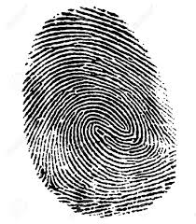
29. Identify the class of fingerprint then identify the details marked. Complete a ridge count.
This is a whorl.

30. Identify the class of fingerprint then circle - 4 ridge endings, 2 islands, 1 dot, 2 bifurcations and do a ridge count (make sure the circles and line show).
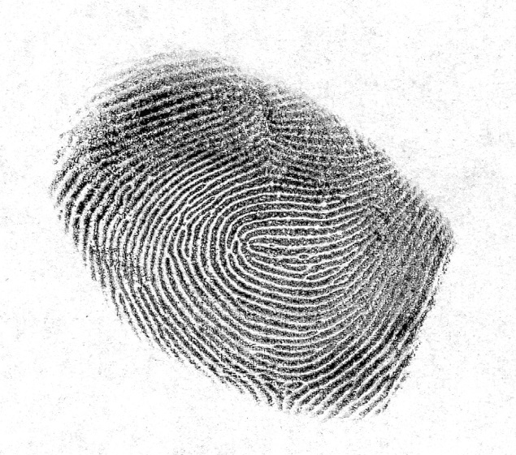This is a loop.

