Atomic Theory Timeline Project 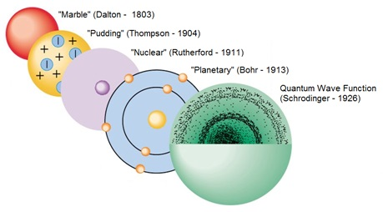
Date Assigned:
Date Due:
You will create a poster of your assigned scientist that shows how they contributed to the development of atomic theory. Your poster must show any important dates related to the atom or subatomic particles and describe any related theories, models, and experiments. Pictures are welcome. These posters will be used by the class to take notes on the development of the modern atomic theory.

Scientists
Democritus/ Aristotle
John Dalton
Sir William Crookes
Robert Millikan
JJ Thomson
Ernest Rutherford
James Chadwick
Max Planck
Albert Einstein
Neils Bohr
Louis de Broglie
Werner Heisenberg
Erwin Schrödinger

Particles, Theories, Models, & Experiments
Atom
Bohr/planetary model
Cathode ray experiment
Cathode ray tubes
Charge to mass ratio of electrons
Dalton’s atomic theory
Electron
Electrons as waves
Gold foil experiment
Neutron
Nucleus
Photoelectric effect
Proton
Quantum concept
Quantum mechanical model
Rutherford’s model
Uncertainty principle

