Evidence of a Chemical Reaction

- A permanent color change
- A permanent odor change 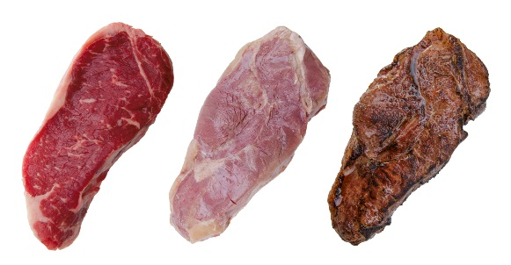
A cooked steak smells very different than a raw steak
- Gas bubbles form 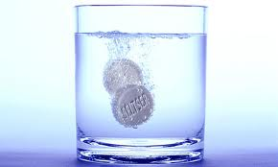
- A precipitate forms 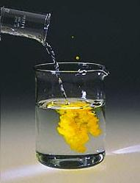
- There is a change in energy (temperature changes)
- Water forms 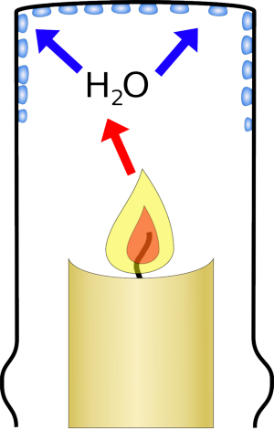

7 Diatomic Elements – always appear as a molecule with 2 atoms bonded together if they are not within a compound

H₂ O₂ N₂ Cl₂ Br₂ I₂ F₂

