Plum pudding model
From Wikipedia, the free encyclopedia

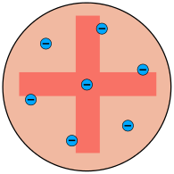
The Plum Pudding model
A Christmas pudding

The plum pudding model is an obsolete scientific model of the atom proposed by J. J. Thomson in 1904. It was devised shortly after the discovery of the electron but before the discovery of the atomic nucleus.
In this model, the atom is composed of electrons (which Thomson still called "corpuscles", though G. J. Stoney had proposed that atoms of electricity be called "electrons", in 1894) surrounded by a soup of positive charge to balance the electrons' negative charges, like negatively charged "plums" surrounded by positively charged "pudding". The electrons (as we know them today) were thought to be positioned throughout the atom, but with many structures possible for positioning multiple electrons, particularly rotating rings of electrons (see below). Instead of a soup, the atom was also sometimes said to have had a "cloud" of positive charge. With this model, Thomson abandoned his earlier "nebular atom" hypothesis in which the atom was composed of immaterial vortices. Now, at least part of the atom was to be composed of Thomson's particulate negative "corpuscles", although the rest of the positively charged part of the atom remained somewhat nebulous and ill-defined.

