Year to Date Review

Nuclear Chemistry
1. Define the following (nuclear fission and nuclear fusion) and which one
a. produces the most elements?
b. is used in nuclear reactors?
c. is for fuel for stars where all the elements heavier than hydrogen are created?
d. requires extremely high temperatures?
When elements undergo radioactive decay, they can spit out one or more of each of these particles:
- alpha particles (α): slow moving helium nuclei, can be stopped by skin or a piece of paper
- beta particle (β): fast moving electrons, can be stopped by a piece of aluminum foil or wood
- gamma rays (γ): massless photons of pure energy, can be partially stopped by 6 inches of lead or 6 feet of concrete. Can do lots of damage to the human body.

States of Matter
2. Match each property to its correct state of matter.
a. solid
b. liquid
c. gas
d. plasma

- close-particles that can slide past each other
- free-moving (random) particles that are relatively far apart from each other
- closed-packed particles that cannot do much more than vibrate in position
- free-moving particles in which the electrons have been ripped off the atom, creating charged particles, occurs at high temperatures.
- Definite shape and definite volume
- No definite shape or volume
- Definite volume but not shape
- Particles are in constant, random motion. The speed of the particles is based on their kinetic energy, or energy of motion. The faster the particles, the harder they hit each other and the walls of their containers. When you have gases, the harder the particles hit the walls of the flexible container, the larger the container will get.
- Physical Properties/Changes – can be observed without changing the substance’s composition. (It’s still the same substance!)
- Chemical Properties/Changes – can be observed when a substance changes composition. (Something new formed!)

3. Determine if the following properties/changes are physical or chemical.
a. Oxygen gas is odorless and colorless.
b. Copper turns green when exposed to the environment.
c. The density of water is 1.00g/cm³.
d. Copper conducts electricity.
e. Gold is nonflammable.
f. Baking soda reacts with vinegar.
g. The melting point of gallium is 85.6°F (30°C).
h. The silver spoons tarnished and turned black.

Pure Substances vs. Mixtures
Matter
Anything that takes
up space & has mass

Pure Substances Mixtures
Substance that Substance that
has definite & constant has variable
composition composition

Elements Compounds Heterogeneous Homogeneous
One type of 2 or more can see each blended, cannot
Atom atoms bonded component see each
together in mix component in mix

Examples
- element = iron, tungsten, chlorine
- compound = water, carbon dioxide, iron (III) chloride
- heterogeneous mix = Chex mix, dirt
- homogeneous mix = air, soda, salt water

- Physical vs. Chemical
  - Properties (nouns) & Changes (verbs)
    - Physical properties and changes can be observed WITHOUT changing the substance’s composition
      - Examples – tearing, boiling, freezing, density, melting point, solubility
      - Can be used to separate mixtures by
        - Magnets
        - Size
        - Solubility (ability to dissolve)
        - Density
        - Filtration
        - Chromatography
        - Distillation
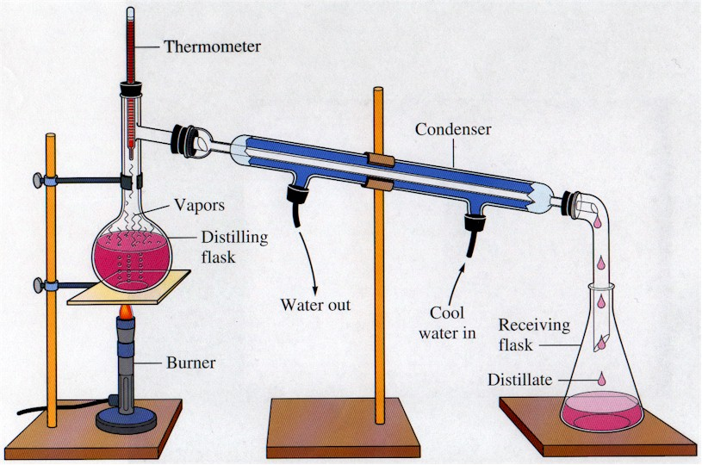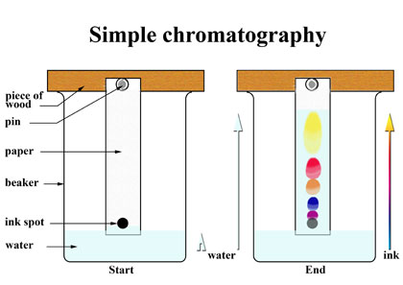

    - Chemical properties and changes can ONLY be observed by changing the substance into a completely NEW substance.
      - Examples – reactivity, flammability, rusting, digesting, decomposing, oxidizing
      - Can be used to change pure substances into new pure substances through chemical reactions
4. Determine if the following substances are elements, compounds, homogeneous mixtures or heterogeneous mixtures:
a. copper b. Lucky Charms cereal
c. air d. oxygen
e. carbon monoxide e. hot coffee
5. Determine if the following are chemical properties/changes or physical properties/changes:
a. A burning tire
b. Freezing ice cubes
c. The density of water is 1.0g/cm³.
d. Rubidium will catch on fire if dropped in water.
e. Platinum is a silvery-white color.
f. Copper (II) chloride dissolves in water.
6. If gallium melts at 29.78°C and boils at 2403.0°C, what is it’s state of matter at it is in your hand? Keep in mind that your normal body temperature is 37.0°C.
7. If you left a cold glass of iced tea (temperature = 2ºC) sitting out in a room with a temperature of 25 C, the iced tea will eventually reach equlibirium with the room. What do you think the temperature of the iced tea will be at that time?

Nomenclature (Names and Formulas!)
See nomenclature flow charts! If you don’t have yours anymore, you can find them on my blog!

8. Write either the name or the formula for each substance. (This is NOT a matching exercise.) They can be any type: type I ionic, type II ionic, type III covalent, or acids. YES- you MUST know the polyatomic ions!
a. sodium sulfide b. HCl
c. gold (III) fluoride d. N₂O₅
e. carbonic acid f. Ca(NO₃)₂
g. dihydrogen monoxide h. H₃PO₃
i. lead (IV) sulfate j. Fe₂(C₂O₄)₃

Chemical Reactions
- Evidence a chemical reaction has occurred. One of these pieces of evidence must be present to understand that a chemical reaction has occurred.
  - A precipitate occurs (that means a solid forms)
  - Bubbles form
  - Water forms
  - There is a change in energy (the substance gets hotter or colder)
- Writing skeleton equations- change the reactants and products into their formulas. Separate reactants from products by a yield sign (), and don’t forget the states of matter: solid (s), liquid (l), gas (g), and aqueous (aq).
  - Don’t forget the 7 diatomic elements: H₂, O₂, N₂, Cl₂, Br₂, I₂, F₂

9. Write skeleton equations for the following reactions:
a. Solid sodium chloride reacts with gaseous fluorine gas to produce solid sodium fluoride and chlorine gas.
b. Solid potassium chlorate decomposes into solid potassium chloride and oxygen gas.
c. Solid sulfur (S₈) reacts with oxygen in the air to produce solid gasesous sulfur trioxide.
d. An aqueous solution of hydrochloric acid reacts with solid calcium carbonate to produce a solution of calcium chloride, water, and carbon dioxide gas.
e. Liquefied propane gas (C₃H₈) is burned in many gas grills using oxygen from the air to produce carbon dioxide gas and water vapor.

- Balancing chemical equations – using subscripts to make sure you have the same number of atoms of each element on both the reactants and products sides of the equation.

10. Balance the equations below:
a. N₂ (g) + H₂ (g) NH₃ (g)
b. AlBr₃ (aq) + K₂SO₄ (aq) Al₂(SO₄)₃ (aq) + KBr (aq)
c. C₅H₁₂ (l) + O₂ (g) CO₂ (g) + H₂O (g)
d. Ag₂O (s) Ag (s) + O₂ (g)
e. Na (s) + Fe(NO₃)₃ (aq) Fe (s) + NaNO₃ (aq)

- 5 Types of Reactions
  - Synthesis – 2 or more reactants combine to make 1 product
  - Decomposition – 1 reactant breaks down into 2 or more products
  - Single-replacement – an element replaces another element in a compound
  - Double-replacement – 2 compounds switch ions
  - Combustion – a hydrocarbon reacts with oxygen gas to produce carbon dioxide and water
11. Identify the type of reaction for each equation in #9 and #10.

Moles
- Molar Mass – the sum of the atomic masses for each atom of each element in the compound
  - Example- Ca(NO₂)₂
Ca: 1 × 40.08g = 40.08g
N: 2 × 14.01g = 28.02g
O: 4 × 16.00g = 64.00g
132.10g
- % Composition – determine the % of each element by mass in a compound
  - % element = mass of element × 100
molar mass
  - Example – Find the % of each element in Ca(NO₂)₂. (I will use the molar mass example from above for this.) You can check your answers by adding your final %’s up, they should be very close to 100%.
    - %Ca = 40.08g × 100 = 30.34%
132.10g
    - %N = 28.02g × 100 = 21.21%
132.10g
    - %O = 64.00g × 100 = 48.45%
132.10g

12. Find the molar mass and % composition for the following compounds:
a. CuBr₂ b. Co₂(CO₃)₃

- Mole Calculations
  - Use your mole map to guide you in solving mole problems. Remember to always figure out your given and unknown first! That way you know where to start and where to end up on your mole map.

MOLE

Molar mass 6.02× 10²³
1 mol 1 mol

1 mol 1 mol
molar mass 6.02 × 10²³

Mass (g) Particles
(atoms, molecules, formula units)

13. How many moles are in 34.5 g of water?
14. How many molecules are in 0.456 moles of water?
15. How many moles are in 21.1g of calcium chloride?
16. How many moles are in 6.789 × 10²² formula units of calcium chloride?
17. How many atoms are in 99.99g of nitric acid, HNO₃?
18. What is the mass, in grams, of 7.87 × 10²⁵ molecules of sulfur trioxide?

- Empirical and Molecular Formulas
  - What’s the difference?
    - A molecular formula is the true formula for a substance, for example, tetraphosphorous decoxide is P₄O₁₀.
    - An empirical formula has the coefficients reduced down to their lowest possible ratio, for example, that P₄O₁₀ can be reduced to an empirical formula of P₂O_{5.}
  - Calculating an empirical formula- the steps!
    - 1. Assume you have 100g of the substance and change the % to grams (Just change the % sign to g- no math involved here people, it’s all in your head!)
    - 2. Convert the grams to moles. (We are finding the mole ratio of one element to another soon!)
    - 3. Look at your moles you just calculated, find the smallest amount. Then divide each mole by that smallest answer.
    - 4. Get whole #’s (or very close to whole #’s)? Then those are the subscripts for your formula.
    - 5. Didn’t get a whole #? Did you get something like .5? Then multiply everything by 2 to get rid of the decimal and you now have your subscripts for your formula!

19. Write the empirical formula for the following substances. If it already is an empirical formula, let it be!
a. C₆H₁₄ b. C₃H₈
c. C₆H₁₂O₆ d. Co₂(CO₃)₃
20. A compound has been analyzed and determined to contain 32.38% Na, 22.65% S, and 44.99% O. Determine its empirical formula.

Stoichiometry – determining how much product can be made from a specific amount of reactants. It is based on the law of conservation of mass and uses MOLE RATIOS to convert between substances!

- Mole ratio = moles of unknown
moles of given
- If you want to see a step by step procedure for doing stoichiometry, please go to your notes or the following website-http://misterguch.brinkster.net/stoichiometryexplained.pdf
- Limiting and Excess reactants
  - Limiting reactants control how much product can be made during a chemical reaction because you run out of that reactant first!
  - An excess reactant is one in which you have more than enough for the reaction to run to completion.

21. Use the balanced equation to answer the following questions:
3 K (s) + Au(NO₃)₃ (aq) Au (s) + 3 KNO₃ (aq)
- How many moles of potassium nitrate are produced from 21.0 moles of potassium?
- How many grams of gold are produced from the reaction of 1.50 moles of potassium with excess gold (III) nitrate?
- How many moles of potassium nitrate produced from the reaction of 50.00g of gold (III) nitrate with excess potassium?

Atomic Structure
- Subatomic Particles
  - Inside the nucleus of an atom
    - Protons (p⁺)
      - Positively charged particles, charge = +1
      - # of protons in the nucleus identifies an element, is the atomic number
    - Neutrons (n⁰)
      - Particles with no charge, charge = 0
      - They maintain the stability of the atom, in a nuclear/radioactive sense.
    - Mass number = #p⁺ + #n⁰
      - Is ONLY the same as a round atomic mass if you are describing the most common isotope of that element!
        - Isotopes= are atoms of an element that have the same atomic number but different mass numbers (they have different #’s of neutrons!)
  - Outside the nucleus
    - Electrons (e⁻)
      - Negatively charged particles, charge = -1
      - Equals the # p⁺ in a neutral atom (not an ion)
      - They are involved in bonding atoms to form compounds

- Fill in the chart below. You may use your periodic table also.
Element | atomic # | mass # | # protons | # electrons | # neutrons
sulfur |  | 32
 | 48 |  |  |  | 64
 |  | 181 | 73
 |  |  |  | 99 | 153
- Electron Configurations – tell you the placement of the electrons within the energy levels (orbitals) and sublevels within the atom
  - The ground state is the lowest energy levels for the electrons and how we write electron configurations.
  - Sublevels- each type of sublevel can hold a different amount of electrons
    - s = 2 e⁻, p = 6e⁻, d = 10e⁻, f = 14 e⁻

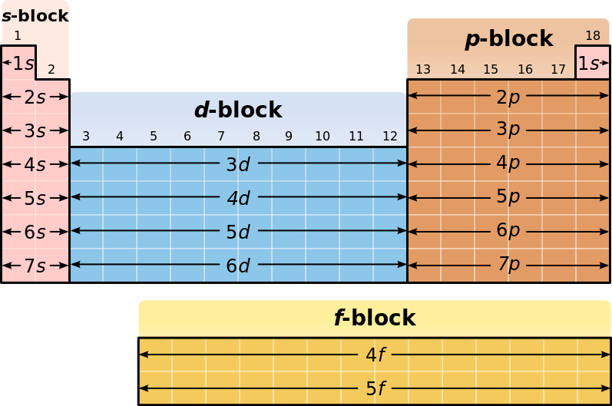
7s | 7p
6s | 6p | 6d
5s | 5p | 5d | 5f
4s | 4p | 4d | 4f
3s | 3p | 3d
2s | 2p
1s
 | * nucleus

- Write ground state electron configurations for the following elements:
  - Ti c. Br
  - Ni d. Sr
- Which are the correct noble gas configurations for the elements below:
  - Ti
    - [Ar]4s²4d²
    - [Ar]4s²3d²
    - [K]4s¹3d²
  - S
    - [S]3s²3p⁴
    - [Ne]3s⁶
    - [Ne]3s²3p⁴
- Place the electrons in the proper energy level for the Bohr planetary models of the following electrons.

- Electrons and Light
  - Electrons can give off light when they are excited. This means that the electron has absorbed energy and moved to a higher energy level where it is unstable. In order to become stable again and move back down to the ground state, the electron releases a photon of energy. This photon has a wavelength and a frequency in the visible light spectrum that we can see. We use this to identify elements (Remember the Flame Test Lab?) and to determine the age of starts. We also use this property to make colorful fireworks!
    - The lower the wavelength, the higher the frequency and the more energy the photon has!
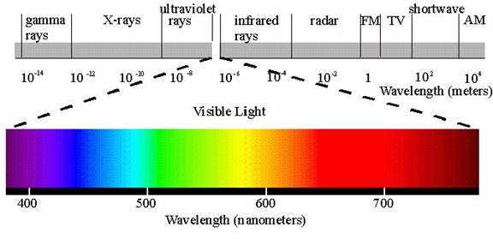

Chemical Bonds
- Ionic Bonds – occur between a metal and a nonmetal
  - An electron is transferred from the metal to the nonmetal
    - The metal becomes + charged and the nonmetal becomes – charged.
    - Shown by drawing electron dot diagrams
  - Very strong polar bonds, takes a LOT of energy to break an ionic bond. You can tell that a bond is very polar by noticing how far apart the two elements are on the Periodic Table. A general rule is that the farther apart the 2 atoms are, the stronger the polarity between them. Therefore, ionic compounds are hard crystals with very high melting and boiling points!
- Covalent Bonds- occur between 2 nonmetals
  - An electron is shared between the 2 nonmetals because neither one is strong enough (has a high enough electronegativity) to take the electron from the other element.
    - Shown by drawing Lewis structures
  - Strong bonds but not as strong as an ionic bond so these compounds have lower melting and boiling points.

- Determine if the following compounds have ionic or covalent, or both ionic and covalent bonds. Y
  - CO₂
  - FeF₂
  - NH₃
  - CaBr₂
  - MgSO₄
  - KC₂H₃O

Periodic Table and Periodic Trends
- Label the periodic table legend below with the following:
Noble gases, alkali metals, transition metals, halogens, inner transition metals, alkaline earth metals, metalloids
 | 1 | 2 | 3 | 4 | 5 | 6 | 7 | 8 | 9 | 10 | 11 | 12 | 13 | 14 | 15 | 16 | 17 | 18
1
2
3
4
5
6
7
legend

- What are groups on the periodic table and how many are there?
- What are periods on the periodic table and how many are there?

- Periodic Trends
  - When the periodic table is set up as it is, properties of the elements show reliable trends. So it is possible to predict how an element is going to react or act based on its location on the periodic table.
  - In class, we discussed 4 properties: atomic radius, ionic radius, ionization energy (energy needed to remove an electron from the atom) and electronegativity (the attraction the nucleus of an atom has for another atom’s electrons).
    - Francium (Fr) vs. Fluorine (F)
 | Fr | F
atomic radius | largest | smallest
ionic radius | largest | smallest
ionization energy | smallest | highest
Electronegativity | smallest | highest
- Based on the information above, rank these elements, Sc, Br, and Ni, in order of
  - Increasing atomic radius
  - Decreasing ionic radius
  - Increasing ionization energy
  - Decreasing electronegativity
- Based on the information above, rank these elements, Se, Pb, and F, in order of
  - Increasing atomic radius
  - Decreasing ionic radius
  - Increasing ionization energy
  - Decreasing electronegativity

Heat
- Flow of energy from a higher temperature to a lower temperature
- Measured in joules (J) or calories (cal) or kilocalories (Cal)
- Exothermic vs Endothermic Processes
  - Exothermic processes – occur when heat is released from the system into the surroundings. ΔH is a negative number
  - Endothermic processes – occur when heat is added to the system from the surroundings. ΔH is a positive number.

- On a cold day outside watching a football game, you decide to get a huge hot chocolate to hold.
  - If the hot chocolate is the system, is it endothermic or exothermic?
  - If your hands are the system, are they endothermic or exothermic?
- In lab, you add some nitric acid to water and notice that the beaker gets warm, is this an endothermic or exothermic process?
- In the summer, plants produce glucose (their energy source) by reacting carbon dioxide, water and heat and light from the sun. Is this process, endothermic or exothermic?

- Calculating heat
  - q = mC∆T
    - If q is negative, it’s an exothermic process
    - If 1 is positive, it’s an endothermic process

- A 15.75g piece of iron absorbs 1086.75 J of heat and its temperature changes from 25°C to 175°C. Calcuate the specific heat capacity of iron.
- How much heat is needed to raise the temperature of a 2300.g aluminum lawn chair from 2°C to 16°C? The specific heat capacity of aluminum is 0.90J/g°C.
- How much heat is released when 454g of zinc are cooled from 96.0°C to 28.0°C? The specific heat capacity of zinc is 0.386J/g°C.

