The Quantum Mechanical Model of the Atom 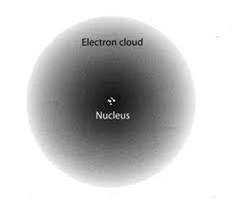

The Rutherford planetary model of the atom is often what sticks in students’ minds. It provides a neat and familiar picture of electrons orbiting a central nucleus like planets around the Sun. Because of this, it can be challenging to replace this picture with one that more accurately represents the quantum-mechanical model used by modern physicists: an atom with a tiny nucleus with probability waves instead of sharp orbits to describe the distribution of electrons, which have fuzzy positions but definite energy levels. Nevertheless, students should get a glimpse of this more modern model.
The locations and motions of the electrons are described by their matter waves. These wave patterns, which are written as equations when they are too difficult to sketch, predict the probability of finding an electron in a given region of the atom. They provide the betting odds, never the certainty. Yet the betting is useful: it predicts definite energy levels; it explains chemical bonding by electrons; and, when applied to particles in the nucleus, they not only explain the known random laws of radioactivity but also predict new nuclear particles.
Although this picture dispenses with electrons in neat, sharply defined orbits, it still gives them fixed energy levels. Electrons in the higher energy levels are more likely to be found in the outer regions of an atom, some distance out from the nucleus.
Where did this model come from?
Bohr’s development of Rutherford’s planetary model had begun the process of introducing quantum theory to the structure of the atom (seeDeveloping a model of the atom: radioactive atoms). Bohr introduced the idea of stationary states in which the atom was stable. Transitions between these states explained the existence of spectral lines. In the case of hydrogen, he was able to derive energy levels: transitions between his predicted energy levels matched the lines in the hydrogen spectrum. However, his model could not predict energy levels for any other atoms (though those of the hydrogen-like alkali metals could be approximated).
It took the work of Heisenberg and Schrödinger to separately come up with ways of describing more fully the quantized energy levels of atoms. Heisenberg used matrices and Schrödinger developed a wave equation. It is solutions of Schrödinger‘s equation that provide pictures of electrons’ probability densities around the nucleus of an atom.

