Democritus

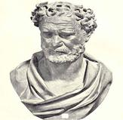
Democritus was born in Abdera, Greece in 460BC. He lived to be 90 years old, dying in the year 370BC. He studied natural philosophy in Thrace, Athens, and Abdera, Greece. He enjoyed studying geometry as well. Democritus traveled to many places some of which including India, Egypt, and Babylon. Democritus was never married.

His mentor, Leucippus, originally came up with the atomic theory, but it was then adopted by Democritus. The atomic theory stated that “The universe is composed of two elements: the atoms and the void in which they exist and move.” According to Democritus atoms were miniscule quantities of matter. Democritus hypothesized that atoms cannot be destroyed, differ in size, shape and temperature, are always moving, and are invisible. He believed that there are an infinite number of atoms. This hypothesis was created in 465BC.

This is Democritus' atomic theory exactly:

1.All matter consists of invisible particles called atoms.

2. Atoms are indestructible.

3. Atoms are solid but invisible.

4. Atoms are homogenous.

5. Atoms differ in size, shape, mass, position, and arrangement.

->Solids are made of small, pointy atoms.

->Liquids are made of large, round atoms.

->Oils are made of very fine, small atoms that can easily slip past each other.
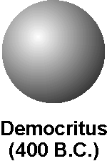

This was Democritus’ atomic model. It was simply a round sphere with no electrons, protons, or neutrons. Democritus created the first atomic model. His contribution helped people with understanding the idea of an atom, and helped other scientists further look into the science of the atom and its generic makeup.

Quick Facts!
- He published over 70 books.
- Born to a family of wealth.
- Very close with his father.
- He studied pythagoreanism for a brief part of his life.
- Enjoyed traveling; visited many places.
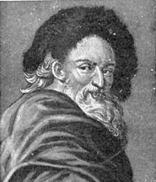
For further information, please consider checking out these sites.
- By, Initiated. "Democritus Biography." Scribd. Web. 19 Nov. 2010. <http://www.scribd.com/doc/26307868/Democritus-Biography>.

- "Democritus Biography | BookRags.com." BookRags.com | Study Guides, Lesson Plans, Book Summaries and More. Web. 19 Nov. 2010. http://www.bookrags.com/biography/democritus/.
- Hakala, Sarah J. "G) Interesting Facts." Democritus. 1 Jan. 2010. Web. 29 Nov. 2010. <http://democritus3.tripod.com/home/id7.html>

