Aristotle

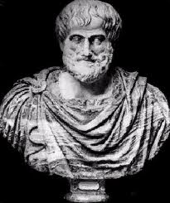
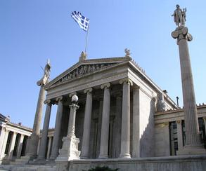
Aristotle's Life
Aristotle was born in 384 BC in Stagira, Greece. He lived and worked in Greece for almost all of his life. Aristotle's father, Nicomachus, was a physician, and taught Aristotle during his early childhood. He lived with his parents up until they died when he was about ten years old. After the tragic death of his parents, Aristotle lived with his guardian Proxenus. Starting at age 17 he went to a school called the Academy, in Athens, were he studied under Plato, whom he greatly admired. Aristotle studied and later taught at the Academy for 20 years. He studied a very wide variety of sciences. These sciences include logic, philosophy, ethics, physics, biology, psychology, politics, and rhetoric.
Aristotle married his first wife, Pythias, in 345 BC. Pythias was the niece of King Hermias, a friend of Aristotle. After Pythias' death, Aristotle remarried to Herpyllis. Aristotle and Herpyllis had a son whom they named Nicomachus.
One of the students Aristotle taught was Alexander the Great. It has been said that Aristotle's great teachings lead to the success of Alexander the Great. In 335 BC, Aristotle opened his own school, Luceum, and ran it for 12 years. During this time he wrote many science books on philosophy and meterology.
Aristotle was a great philosopher and used both inductive and deductive reasoning. The four categories of Aristotle's philosophy are Logic, Theoretical Philosophy (Math and Physics), Practical Philosophy (Ethics and Politics), and Poetical Philosophy (Poetry and the Fine Arts). When the Atomic Theory was discovered, Aristotle did not believe in it. He believed that all substances were made of Fire, Water, Air, and Earth. He taught his beliefs, and he was so well known for his teachings, most believed him to be right. Shortly before Aristotle's death, Alexander the Great fell out of power in Athens and the new government associated Aristotle with Alexander the Great. This caused Aristotle to be forced to flee Athens. Soon after he died, complaining of stomache pains, in 322 BC.
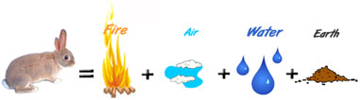

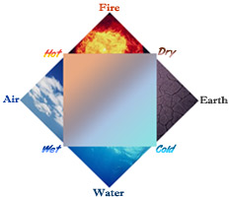
Beliefs on the atomic theory
Aristotle did not believe in the atomic theory and he taught so otherwise. He thought that all materials on Earth were not made of atoms, but of the four elements, Earth, Fire, Water, and Air. He believed all substances were made of small amounts of these four elements of matter. Most people followed Aristotle’s idea, causing Democritus’ idea- which was that all substances on Earth where made of small particles called atoms- to be over looked for about 2,000 years! Aristotle's view was finally proven incorrect and his teachings are not present in the modern view of the atom.
Fun Facts:
- Aristotle believed that the Earth was the center of the Universe
- This, and his beliefs on the atomic theory, are both false!
- Only approximately one-third of Aristotle's books and writings have been save. Others have been lost or destroyed.
- Aristotle developed the Scientific Method
For more information, check out these links!
"Aristotle." Angelfire: Welcome to Angelfire. Web. 30 Nov. 2010. http://www.angelfire.com/sc2/atomtheory/aristotle.html
"Aristotle." Philosophy Pages. Web. 30 Nov. 2010. http://www.philosophypages.com/ph/aris.htm
﻿http://science.jrank.org/pages/630/Atomic-Theory-History.html
"Visionlearning Library." Visionlearning. Web. 30 Nov. 2010. http://www.visionlearning.com/library/
"Aristotle's Life." LearningAlived Redirect Page. Web. 30 Nov. 2010. http://atschool.eduweb.co.uk/sirrobhitch.suffolk/portland%20state%20university%20greek%20civilization%20home%20page%20v2/docs/11/life.htm
"Aristotle Bio of Ancient Philosopher 384-322 B.C." Brian Taylor SEO Web Site Developer Search Engine Optimization. Web. 30 Nov. 2010. http://briantaylor.com/aristotle.htm#ideas
"Aristotle." Windows to the Universe. Web. 30 Nov. 2010. http://www.windows2universe.org/people/ancient_epoch/aristotle.html
"Biography of Aristotle | List of Works, Study Guides & Essays | GradeSaver." Study Guides & Essay Editing | GradeSaver. Web. 30 Nov. 2010.
http://www.gradesaver.com/author/aristotle/

