A.P. Chemistry Summer Assignment 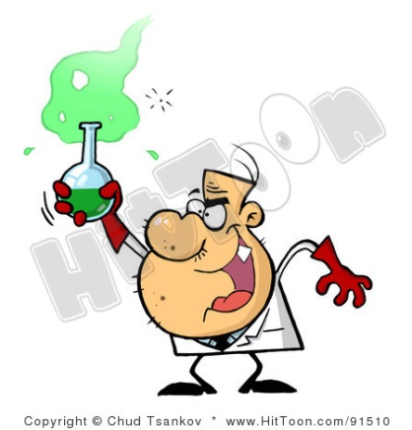
Once class starts, we have 78 days until the A.P. Exam on May 4th and a LOT of information to cover. That means you will be spending time outside of class studying. For example, reading the chapter and taking notes on the chapter before coming in to class and perhaps watching a short video outside of class as well. In class, we will be moving fast and working on practice problems and labs.
First you need access to the Chemistry book online. It is Brown/LeMay/Bursten/ Murphy. Chemistry: The Central Science, 11e.

- Register at www.pearsonschool.com/access
2. Enter the first 6 letters of your code below
3. Click on Covered Titles to Select Discipline and Title
4. Accept - Pearson License Agreement
5. Access Information -
* Enter or Create your username & password
* Enter the appropriate access code below:
Student: SSNAST-ATOLL-MOUSY-PRIVY-POTTO-LURES
6. Account Information - complete or verify your name & school information
7. Confirmation & Summary

Once you are able to log in, please complete the following. It is due the SECOND DAY OF CLASS, with 20% being taken off for each day late.

Assignment: You must show work for any mathematical calculations done to earn credit.
Read Chapter 1: Introduction: Matter and Measurement
Complete p.30-35 #2, 3, 10, 12, 14, 18, 20, 22, 23, 28, 32, 36, 38, 40, 42, 44, 50, 52, 54, & 57

Read Chapter 2: Atoms, Molecules, and Ions
Complete p. 69-77 #2, 3, 5, 7, 8, 10, 14, 20, 22, 24, 26, 32, 34, 38, 42, 44, 46, 48, 50, 58, 60, 64, 66, 68, 70, 72, 74

