Fall 2013 Honors Chemistry Final Review

Scientific Method – define the following
- Observation
- Hypothesis
- Experiment
- Data/Analysis
- Theory or Scientific Law
1. Honeybees play an important role in agriculture, by pollinating at least 90 different species of food plants, worth about 15 billion dollars in the U.S. alone. As a result, beekeeping or apiculture is a multi-million dollar business. However over the last year, honeybee populations are crashing (Colony Collapse Disorder) with hives dying off in less than a week, without an obvious cause. Ian Lipkin, a senior researcher in the Epidemiology (infectious disease) Department of Columbia University's Mailman School of Public Health believed the cause to be a pathogen (virus, bacteria or fungus) of some sort. Use the information given to answer the following questions.
- What is the initial observation?
- What is the hypothesis?
- Design an experiment to test your hypothesis.
- If you did your experiment and your hypothesis was supported, what would your data indicate?
- If you did your experiment and your hypothesis was NOT supported, what would your data indicate?

Lab Safety
2. Explain the reasoning behind the following lab safety rules
a. Don’t wear loose clothing or hair or dangling jewelry.
b. When heating a test tube, never point the open end toward any person.
c. Wear closed toes shoes.
d. Don’t eat or drink in the lab.
e. No horseplay in the lab.

Lab Equipment
3. Identify the following pieces of lab equipment.

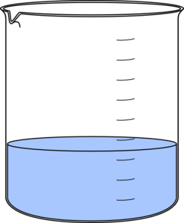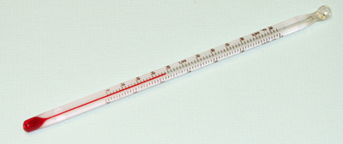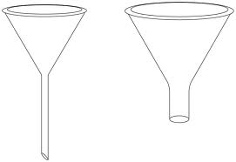

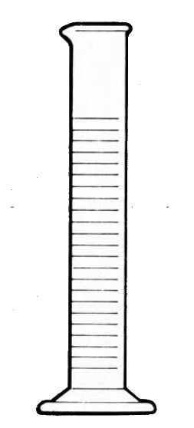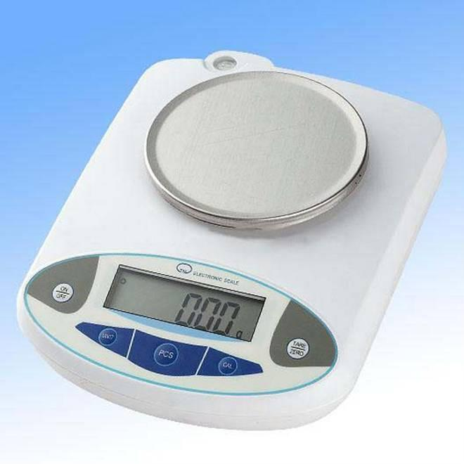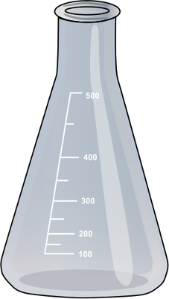

Scientific Notation – is a way of writing very large or very small numbers.
- To put a number into scientific notation, move the decimal point between the 1st two numbers so that it makes a number between 1 -10.
- Then, as × 10 raised to a power of how many times you moved that decimal point. The power will be negative if the number is a decimal and positive if it is a large number.
- Examples,
  - – Mass of a proton = 0.000 000 000 000 000 000 000 000 00 000 16726178g

    - Move the decimal point between the 1 and the 6 so you get … 1.6726178
    - Add × 10 to that and count how many times you moved your decimal point AND you should get…

    - 1.6726178 × 10⁻³⁰ g
  - Mass of the Eiffel Tower = 7300000000 g
    - 7.3 × 10⁹ g
4. Covert these measurements into or out of scientific notation.
a. 0.00000678s
b. 19100000J
c. 0.000546g
d. 12110000000°C
e. 8.76 × 10⁴atm
f. 3.42 × 10⁻⁴ mol

Significant Figures – this seems to be everyone’s Achille’s heel so we will do this one in detail.
- What numbers are considered significant?
  - Anything that is NOT a zero is significant!
  - Captured zeroes are significant.
  - Leading zeroes are NEVER significant, they’re just place holders (That’s what makes writing in scientific notation so usefull, don’t have to worry about them pesky leading zeroes. If it’s not significant, it isn’t written.)
  - Trailing zeroes are significant ONLY if there is a decimal somewhere in that number (No, it does NOT have to be anywhere near the zeroes!)
    - Examples
      - 123053.96 g 8 S.F.
      - 0.000543 m 3 S.F.
      - 123.4560000 J 10 S.F.
- Rounding with significant figures
  - If you are rounding a number to significant figures, always look at the number right after the LAST significant figure. If it is 5 or greater, round up the last significant figure ONLY. If it is less than 5, do nothing but drop the insignificant figures in the number.

    - Examples, rounding each to 4 significant figures
      - 876.0023 mg 876.0 mg
      - 0.00913457 km 0.009135 km
      - 1920.800000 s 1921 s
      - 0.054684986 J 0.05468 J
      - 2 m 2.000 m
5. How many significant figures are in these measurements below?
a. 100.0g
b. 0.5406040 m
c. 0.000005 s
d. 0.0034565400 J
6. Round these measurements to 3 significant figures.
a. 100.0g
b. 0.5406040 m
c. 0.000005 s
d. 0.0034565400 J

Nuclear Chemistry
7.Define the following (nuclear fission and nuclear fusion) and which one
a. produces the most elements?
b. is used in nuclear reactors?
c. is for fuel for stars where all the elements heavier than hydrogen are created?
d. requires extremely high temperatures?
When elements undergo radioactive decay, they can spit out one or more of each of these particles:
- alpha particles (α): slow moving helium nuclei, can be stopped by skin or a piece of paper
- beta particle (β): fast moving electrons, can be stopped by a piece of aluminum foil or wood
- gamma rays (γ): massless photons of pure energy, can be partially stopped by 6 inches of lead or 6 feet of concrete. Can do lots of damage to the human body.

States of Matter
8. Match each property to its correct state of matter.
a. solid
b. liquid
c. gas
d. plasma

- close-particles that can slide past each other
- free-moving (random) particles that are relatively far apart from each other
- closed-packed particles that cannot do much more than vibrate in position
- free-moving particles in which the electrons have been ripped off the atom, creating charged particles, occurs at high temperatures.
- Definite shape and definite volume
- No definite shape or volume
- Definite volume but not shape

- Physical Properties/Changes – can be observed without changing the substance’s composition. (It’s still the same substance!)
- Chemical Properties/Changes – can be observed when a substance changes composition. (Something new formed!)

9. Determine if the following properties/changes are physical or chemical.
a. Oxygen gas is odorless and colorless.
b. Copper turns green when exposed to the environment.
c. The density of water is 1.00g/cm³.
d. Copper conducts electricity.
e. Gold is nonflammable.
f. Baking soda reacts with vinegar.
g. The melting point of gallium is 85.6°F (30°C).
h. The silver spoons tarnished and turned black.

Pure Substances vs. Mixtures
Matter
Anything that takes
up space & has mass

Pure Substances Mixtures
Substance that Substance that
has definite & constant has variable
composition composition

Elements Compounds Heterogeneous Homogeneous
One type of 2 or more can see each blended, cannot
Atom atoms bonded component see each
together in mix component in mix

Examples
- element = iron, tungsten, chlorine
- compound = water, carbon dioxide, iron (III) chloride
- heterogeneous mix = Chex mix, dirt
- homogeneous mix = air, soda, salt water

- Physical vs. Chemical
  - Properties (nouns) & Changes (verbs)
    - Physical properties and changes can be observed WITHOUT changing the substance’s composition
      - Examples – tearing, boiling, freezing, density, melting point, solubility

      - Can be used to separate mixtures by
        - Magnets
        - Size
        - Solubility (ability to dissolve)
        - Density
        - Filtration
        - Chromatography
        - Distillation
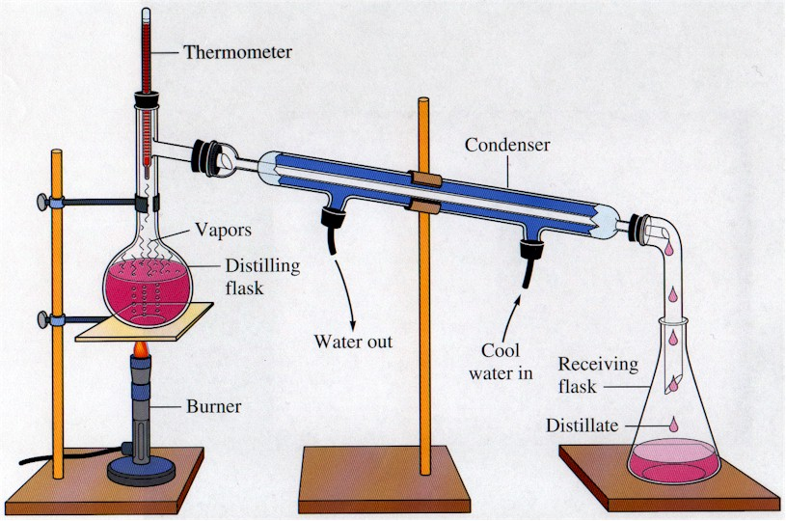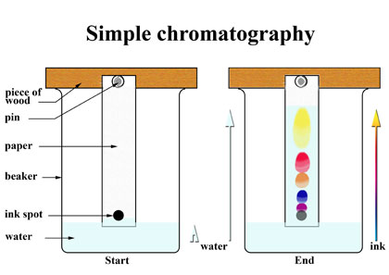

    - Chemical properties and changes can ONLY be observed by changing the substance into a completely NEW substance.
      - Examples – reactivity, flammability, rusting, digesting, decomposing, oxidizing
      - Can be used to change pure substances into new pure substances through chemical reactions
10. Determine if the following substances are elements, compounds, homogeneous mixtures or heterogeneous mixtures:
a. copper b. Lucky Charms cereal
c. air d. oxygen
e. carbon monoxide e. hot coffee
11. Determine if the following are chemical properties/changes or physical properties/changes:
a. A burning tire
b. Freezing ice cubes
c. The density of water is 1.0g/cm³.
d. Rubidium will catch on fire if dropped in water.
e. Platinum is a silvery-white color.
f. Copper (II) chloride dissolves in water.
12. If gallium melts at 29.78°C and boils at 2403.0°C, what is it’s state of matter at it is in your hand? Keep in mind that your normal body temperature is 37.0°C.

Nomenclature (Names and Formulas!)
See nomenclature flow charts!

13. Write either the name or the formula for each substance. (This is NOT a matching exercise.) They can be any type: type I ionic, type II ionic, type III covalent, or acids. YES- you MUST know the polyatomic ions!
a. sodium sulfide b. HCl
c. gold (III) fluoride d. N₂O₅
e. carbonic acid f. Ca(NO₃)₂
g. dihydrogen monoxide h. H₃PO₃
i. lead (IV) sulfate j. Fe₂(C₂O₄)₃

Chemical Reactions
- Evidence a chemical reaction has occurred. One of these pieces of evidence must be present to understand that a chemical reaction has occurred.
  - A precipitate occurs (that means a solid forms)
  - Bubbles form
  - Water forms
  - There is a change in energy (the substance gets hotter or colder)
- Writing skeleton equations- change the reactants and products into their formulas. Separate reactants from products by a yield sign (), and don’t forget the states of matter: solid (s), liquid (l), gas (g), and aqueous (aq).
  - Don’t forget the 7 diatomic elements: H₂, O₂, N₂, Cl₂, Br₂, I₂, F₂
14. Write skeleton equations for the following reactions:
a. Solid sodium chloride reacts with gaseous fluorine gas to produce solid sodium fluoride and chlorine gas.
b. Solid potassium chlorate decomposes into solid potassium chloride and oxygen gas.
c. Solid sulfur (S₈) reacts with oxygen in the air to produce solid gasesous sulfur trioxide.
d. An aqueous solution of hydrochloric acid reacts with solid calcium carbonate to produce a solution of calcium chloride, water, and carbon dioxide gas.
e. Liquefied propane gas (C₃H₈) is burned in many gas grills using oxygen from the air to produce carbon dioxide gas and water vapor.

- Balancing chemical equations – using subscripts to make sure you have the same number of atoms of each element on both the reactants and products sides of the equation.

15. Balance the equations below:
a. N₂ (g) + H₂ (g) NH₃ (g)
b. AlBr₃ (aq) + K₂SO₄ (aq) Al₂(SO₄)₃ (aq) + KBr (aq)
c. C₅H₁₂ (l) + O₂ (g) CO₂ (g) + H₂O (g)
d. Ag₂O (s) Ag (s) + O₂ (g)
e. Na (s) + Fe(NO₃)₃ (aq) Fe (s) + NaNO₃ (aq)

- 5 Types of Reactions
  - Synthesis – 2 or more reactants combine to make 1 product
  - Decomposition – 1 reactant breaks down into 2 or more products
  - Single-replacement – an element replaces another element in a compound
  - Double-replacement – 2 compounds switch ions
  - Combustion – a hydrocarbon reacts with oxygen gas to produce carbon dioxide and water
16. Identify the type of reaction for each equation in #14 and #15.

Moles
- Molar Mass – the sum of the atomic masses for each atom of each element in the compound
  - Example- Ca(NO₂)₂
Ca: 1 × 40.08g = 40.08g
N: 2 × 14.01g = 28.02g
O: 4 × 16.00g = 64.00g
132.10g
- % Composition – determine the % of each element by mass in a compound
  - % element = mass of element × 100
molar mass
  - Example – Find the % of each element in Ca(NO₂)₂. (I will use the molar mass example from above for this.) You can check your answers by adding your final %’s up, they should be very close to 100%.
    - %Ca = 40.08g × 100 = 30.34%
132.10g
    - %N = 28.02g × 100 = 21.21%
132.10g
    - %O = 64.00g × 100 = 48.45%
132.10g

17. Find the molar mass and % composition for the following compounds:
a. CuBr₂ b. Co₂(CO₃)₃

- Mole Calculations
  - Use your mole map to guide you in solving mole problems. Remember to always figure out your given and unknown first! That way you know where to start and where to end up on your mole map.

MOLE

Molar mass 6.02× 10²³
1 mol 1 mol

1 mol 1 mol
molar mass 6.02 × 10²³

Mass (g) Particles
(atoms, molecules, formula units)

18. How many moles are in 34.5 g of water?
19. How many molecules are in 0.456 moles of water?
20. How many moles are in 21.1g of calcium chloride?
21. How many moles are in 6.789 × 10²² formula units of calcium chloride?
22. How many atoms are in 99.99g of nitric acid, HNO₃?
23. What is the mass, in grams, of 7.87 × 10²⁵ molecules of sulfur trioxide?

- Empirical and Molecular Formulas
  - What’s the difference?
    - A molecular formula is the true formula for a substance, for example, tetraphosphorous decoxide is P₄O₁₀.
    - An empirical formula has the coefficients reduced down to their lowest possible ratio, for example, that P₄O₁₀ can be reduced to an empirical formula of P₂O_{5.}
  - Calculating an empirical formula- the steps!
    - 1. Assume you have 100g of the substance and change the % to grams (Just change the % sign to g- no math involved here people, it’s all in your head!)
    - 2. Convert the grams to moles. (We are finding the mole ratio of one element to another soon!)
    - 3. Look at your moles you just calculated, find the smallest amount. Then divide each mole by that smallest answer.
    - 4. Get whole #’s (or very close to whole #’s)? Then those are the subscripts for your formula.
    - 5. Didn’t get a whole #? Did you get something like .5? Then multiply everything by 2 to get rid of the decimal and you now have your subscripts for your formula!

24. Write the empirical formula for the following substances. If it already is an empirical formula, let it be!
a. C₆H₁₄ b. C₃H₈
c. C₆H₁₂O₆ d. Co₂(CO₃)₃
25. A compound has been analyzed and determined to contain 32.38% Na, 22.65% S, and 44.99% O. Determine its empirical formula.

Stoichiometry – determining how much product can be made from a specific amount of reactants. It is based on the law of conservation of mass and uses MOLE RATIOS to convert between substances!

- Mole ratio = moles of unknown
moles of given
- If you want to see a step by step procedure for doing stoichiometry, please go to your notes or the following website-http://misterguch.brinkster.net/stoichiometryexplained.pdf
- Limiting and Excess reactants
  - Limiting reactants control how much product can be made during a chemical reaction because you run out of that reactant first!
  - An excess reactant is one in which you have more than enough for the reaction to run to completion.

- Use the balanced equation to answer the following questions:
3 K (s) + Au(NO₃)₃ (aq) Au (s) + 3 KNO₃ (aq)
- How many moles of potassium nitrate are produced from 21.0 moles of potassium?
- How many grams of gold are produced from the reaction of 1.50 moles of potassium with excess gold (III) nitrate?
- What is the mass, in grams of potassium nitrate produced from the reaction of 50.00g of gold (III) nitrate with excess potassium?
- Determine the limiting reactant if 30.00 moles of potassium reacts with 9.00 moles of gold (III) nitrate.
- Determine the limiting reactant if 1173g of potassium reacts with 3447g of gold (III) nitrate.

Atomic Structure
- Subatomic Particles
  - Inside the nucleus of an atom
    - Protons (p⁺)
      - Positively charged particles, charge = +1
      - # of protons in the nucleus identifies an element, is the atomic number
    - Neutrons (n⁰)
      - Particles with no charge, charge = 0
      - They maintain the stability of the atom, in a nuclear/radioactive sense.
    - Mass number = #p⁺ + #n⁰
      - Is ONLY the same as a round atomic mass if you are describing the most common isotope of that element!
        - Isotopes= are atoms of an element that have the same atomic number but different mass numbers (they have different #’s of neutrons!)
  - Outside the nucleus
    - Electrons (e⁻)
      - Negatively charged particles, charge = -1
      - Equals the # p⁺ in a neutral atom (not an ion)
      - They are involved in bonding atoms to form compounds

- Fill in the chart below. You may use your periodic table also.
Element | atomic # | mass # | # protons | # electrons | # neutrons
sulfur |  | 32
 | 48 |  |  |  | 64
 |  | 181 | 73
 |  |  |  | 99 | 153
- Electron Configurations – tell you the placement of the electrons within the energy levels (orbitals) and sublevels within the atom
  - The ground state is the lowest energy levels for the electrons and how we write electron configurations.
  - Sublevels- each type of sublevel can hold a different amount of electrons
    - s = 2 e⁻, p = 6e⁻, d = 10e⁻, f = 14 e⁻

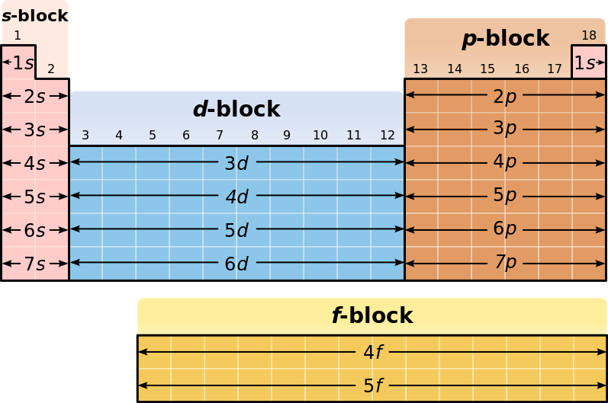
7s | 7p
6s | 6p | 6d
5s | 5p | 5d | 5f
4s | 4p | 4d | 4f
3s | 3p | 3d
2s | 2p
1s
 | * nucleus

- Write ground state electron configurations for the following elements:
  - Ti c. Br
  - Ni d. Sr

- Electrons and Light
  - Electrons can give off light when they are excited. This means that the electron has absorbed energy and moved to a higher energy level where it is unstable. In order to become stable again and move back down to the ground state, the electron releases a photon of energy. This photon has a wavelength and a frequency in the visible light spectrum that we can see. We use this to identify elements (Remember the Flame Test Lab?) and to determine the age of starts. We also use this property to make colorful fireworks!
    - The lower the wavelength, the higher the frequency and the more energy the photon has!
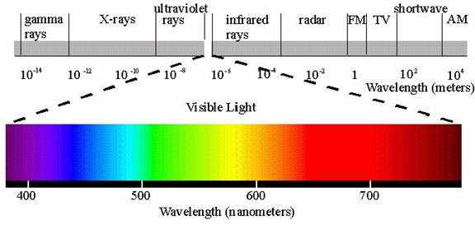

Chemical Bonds
- Ionic Bonds – occur between a metal and a nonmetal
  - An electron is transferred from the metal to the nonmetal
    - The metal becomes + charged and the nonmetal becomes – charged.
    - Shown by drawing electron dot diagrams
  - Very strong bonds, takes a LOT of energy to break an ionic bond. Therefore, ionic compounds are hard crystals with very high melting and boiling points!
- Covalent Bonds- occur between 2 nonmetals
  - An electron is shared between the 2 nonmetals because neither one is strong enough (has a high enough electronegativity) to take the electron from the other element.
    - Shown by drawing Lewis structures
  - Strong bonds but not as strong as an ionic bond so these compounds have lower melting and boiling points.

- Determine if the following compounds have ionic or covalent, or both ionic and covalent bonds.
  - CO₂
  - FeF₂
  - NH₃
  - CaBr₂
  - MgSO₄
  - KC₂H₃O₂

Periodic Table and Periodic Trends
- Label the periodic table legend below with the following:
Noble gases, alkali metals, transition metals, halogens, inner transition metals, alkaline earth metals, metalloids
 | 1 | 2 | 3 | 4 | 5 | 6 | 7 | 8 | 9 | 10 | 11 | 12 | 13 | 14 | 15 | 16 | 17 | 18
1
2
3
4
5
6
7
legend

- What are groups on the periodic table and how many are there?
- What are periods on the periodic table and how many are there?

- Periodic Trends
  - When the periodic table is set up as it is, properties of the elements show reliable trends. So it is possible to predict how an element is going to react or act based on its location on the periodic table.
  - In class, we discussed 4 properties: atomic radius, ionic radius, ionization energy (energy needed to remove an electron from the atom) and electronegativity (the attraction the nucleus of an atom has for another atom’s electrons).
    - Francium (Fr) vs. Fluorine (F)
 | Fr | F
atomic radius | largest | smallest
ionic radius | largest | smallest
ionization energy | smallest | highest
Electronegativity | smallest | highest
- Based on the information above, rank these elements, Sc, Br, and Ni, in order of
  - Increasing atomic radius
  - Decreasing ionic radius
  - Increasing ionization energy
  - Decreasing electronegativity
- Based on the information above, rank these elements, Se, Pb, and F, in order of
  - Increasing atomic radius
  - Decreasing ionic radius
  - Increasing ionization energy
  - Decreasing electronegativity

Reaction Rates &Collision Theory (model)
- Suggests that gas particles move in constant, random motion and only change direction when hit by another particle or the walls of its container.
  - The higher the temperature, the faster the particles move.
  - The faster the particles move, the harder (more force) they hit.
  - The more the force used when the particles hit the walls of the container, the higher the pressure.
  - Decreasing the volume of the container also increases the pressure in the container because the particles are hitting the walls more often!
  - Increasing the amount of stuff (called increasing concentration) in the container can also increase pressure.
- Catalysts – can speed up a reaction too! Catalysts are not actually part of the reaction; their presence makes the reaction work faster! Just like enzymes work in your body!
  - In order for a reaction to work, the reactants must have enough energy to over come the activation energy, E_{a}, barrier (the minimum amount of energy needed for the reaction to occur). This energy is either already stored in the chemical bonds holding the reactants together as compounds or you add heat to get the reaction going.
  - Another way for make a reaction work is to add a catalyst, which lowers the amount of activation energy needed for the reaction to work.
  - The molecules MUST have the correct orientation to react too! If they are off just a little, there is NO reaction!

- Consider the following reaction, 2C₄H₁₀ (g) + 13O₂ (g) 8CO₂ (g) + 10H₂O (g).
  - If the reaction were occurring in a container and it suddenly decreased in volume which increases the pressure, what would happen to the rate of the reaction?
  - If the temperature inside the reaction container were increased, what would happen to the rate of the reaction?
  - If you decreased the concentration of the reactants, what would happen to the rate of the reaction?
  - If the walls of the container were coated in a platinum catalyst, what would happen to the rate of the reaction and why?

- Laws of Thermodynamics
  - 1st Law – Energy cannot be created or destroyed, it’s just converted from one form to another.
    - For example, the chemical energy stored with the bonds of a compound is converted to thermal or heat energy in a chemical reaction.
    - ΔE = q + w
  - 2nd Law –
    - Heat cannot be transfer from a colder to a hotter body. As a result of this fact of thermodynamics, natural processes that involve energy transfer must have one direction, and all natural processes are irreversible.
    - This law also predicts that the entropy of an isolated system always increases with time. Entropy is the measure of the disorder or randomness of energy and matter in a system. Because of the second law of thermodynamics both energy and matter in the Universe are becoming less useful as time goes on.

Kinetic Molecular Theory and States of Matter
- Assumptions of the Kinetic Molecular Theory
  - Gases particles are very tiny and are relatively far apart from each other
  - Collisions between gas particles is elastic- no energy is lost or gained in the collision
  - Gas particles are in constant, rapid, random motion
  - There is no attraction between the gas particles, they ignore each other
  - The temperature of the gas is a measure of the average kinetic energy of the gas particles.
- Atmospheric pressure – the force of the atmosphere pressing down on the earth.
- Evaporation and Boiling
  - A liquid evaporates at the surface of a liquid when some of the liquid particles gain enough kinetic energy to break free from the liquid state and become a gas.
  - Boiling occurs when the pressure created by the gas particles that just escaped from the liquid equals the atmospheric pressure
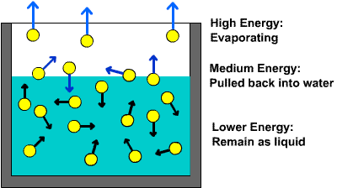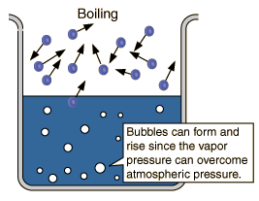

Heat
- Flow of energy from a higher temperature to a lower temperature
- Measured in joules (J) or calories (cal) or kilocalories (Cal)
- Exothermic vs Endothermic Processes
  - Exothermic processes – occur when heat is released from the system into the surroundings. ΔH is a negative number
  - Endothermic processes – occur when heat is added to the system from the surroundings. ΔH is a positive number.

- On a cold day outside watching a football game, you decide to get a huge hot chocolate to hold.
  - If the hot chocolate is the system, is it endothermic or exothermic?
  - If your hands are the system, are they endothermic or exothermic?
- In lab, you add some nitric acid to water and notice that the beaker gets warm, is this an endothermic or exothermic process?
- In the summer, plants produce glucose (their energy source) by reacting carbon dioxide, water and heat and light from the sun. Is this process, endothermic or exothermic?

- Calculating heat
  - q = mC∆T
    - If q is negative, it’s an exothermic process
    - If 1 is positive, it’s an endothermic process

- A 15.75g piece of iron absorbs 1086.75 J of heat and its temperature changes from 25°C to 175°C. Calcuate the specific heat capacity of iron.
- How much heat is needed to raise the temperature of a 2300.g aluminum lawn chair from 2°C to 16°C? The specific heat capacity of aluminum is 0.90J/g°C.
- How much heat is released when 454g of zinc are cooled from 96.0°C to 28.0°C? The specific heat capacity of zinc is 0.386J/g°C.

Solutions
  - Factors that affect the rate at which a solute can dissolve in a solvent
    - 1.
    - 2.
    - 3.
    - 4. Why do each of these factors affect how fast the solute dissolves?
  - Molarity – a measure of concentration
    - M = n/V
      - n = moles of solute, V = volume of solution in L

    - Dilution – when you dilute a solution, you add more solvent but the amount of solute remains the same before and after dilution. Therefore, the moles of solute before you dilute something equals the moles of solute after the dilution.
      - M₁V₁ = M₂V₂
- Calculate the molarity if you dissolve 15.0g of Mg(OH)₂ in 400mL of water.
- How many liters of water were used to create a 0.76M solution of HCl using 5.00g of HCl?
- What mass of NH₃ was used to create a 1.23M solution that has a volume of 1.00L?

- Colligative Properties – properties of a solution that depend only on the number of particles in solution not what the solute is.
    - Boiling Point Elevation – adding a solute to a solution raises the boiling point of the solution because
      - ΔT_{b} = k_{b}× i × m
    - Freezing Point Depression – adding a solute to a solution lowers the freezing point of the solution because
      - ΔT_{f} = k_{f} × i × m
- If you increase the molality of a solution, what will happen..?
  - To its boiling point?
  - To its freezing point?
- Determine the new freezing point of water when enough O₂ gas are dissolved in water to make a 1.78m solution. The K_{f} for water is 1.86°C/m. The original freezing point of water is 0°C.

Acids and Bases
- According to Arrhenius, what is the definition of an acid? A base?
- According to Bronsted- Lowry, what is an acid? A base? A conjugate acid? A conjugate base?
- Write which of the substances is a B.L. Acid, B.L. Base, Conjugate Acid, and Conjugate Base:
  - H_{s}O + H₂SO₄ H₃O⁺ + HSO₄⁻
  - H₂O + NH₃ OH⁻ + NH₄⁺
- What is the difference between a strong acid and a weak acid? Name 7 strong acids and 8 strong bases.
- Calculate the pH & pOH of the following acids and bases.
pH = -log[H⁺] pOH = -log[OH⁻] pH + pOH = 14
    - A 4.04 × 10⁻⁵ M solution of HBr
    - . A 8.88 × 10⁻⁸ M solution of KOH
    - . 45.0g of HNO₃ dissolved in 500. mL of solution.
    - 45.0 g of NaOH dissolved in 500.mL of solution.
- Neutralization M_{A}V_{A} = M_{B}V_{B}
  - For the neutralization between KOH and HCl, determine the volume of 0.75M KOH you would need to titrate 0.0250L of 0.85M HCl.

