A.P. Chemistry Practice Problems- Part B

IMFs ( Ch 11)
- Which type of IMF operates between
  - All molecules?
  - Polar molecules?
  - The hydrogen atom of a polar bond and a nearby small electronegative atom?
- What type of IMFs must be overcome to convert each of the following from a liquid or solid to a gas:
  - I₂
  - CH₃CH₂OH
  - H₂Se
- Propyl alcohol (CH₃CH₂CH₂OH) and isopropyl alcohol [(CH₃)₂CHOH], whose models are shown below have boiling points of 97.2°C and 82.5°C, respectively. Explain why the boiling point of propyl alcohol is higher, even though both have the molecular formula C₃H₈O.
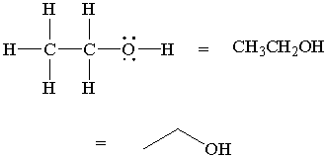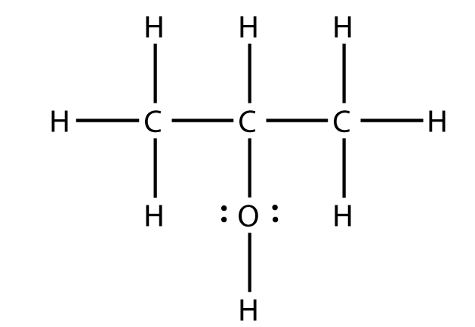
propyl alcohol isopropyl alcohol

Solids and Liquids (Ch 11)
- Why do surface tension and viscosity decrease when the temperature increases?
- Distinguish between cohesive and adhesive forces. What adhesive and cohesive forces are involved when a paper towel absorbs water?
- Label the phase change diagram. Solid, liquid, gas, melting/freezing, evaporating/condensing, heat of vaporization, heat of fusion.
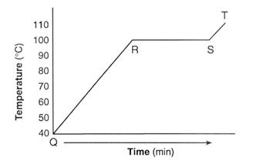

- True or false:
  - CBr₄ is more volatile than CCl₄.
  - CBr₄ has a higher boiling point than CCl₄.
  - CBr₄ has weaker IMFs than CCl₄.
  - CBr₄ has a higher vapor pressure at the same temperature than CCl₄.
- What kinds of attractive forces exist between the particles in
  - Molecular crystals
  - Covalent-network crystals
  - Ionic crystals
  - Metallic crystals
- What type of crystal (See #77) make up each of the following solids?
  - CaCO₃ d. C₁₂H₂₂O₁₁ (table sugar)
  - Pt e. benzene, C₆H₆
  - ZrO₂ (melting pt = 2677°C)

Solutions (Ch 13)
- Use the solubility curve below to answer these questions.
  - If you add 50g of KNO₃ to 100g of water 40°C, is the solution unsaturated, saturated, or supersaturated?
  - If you added 30g of KClO₃ to 100 g of water at 70°C, is the solution unsaturated, saturated, or supersaturated?
  - What is the solubility of NaCl in 100g of water at 10°C?
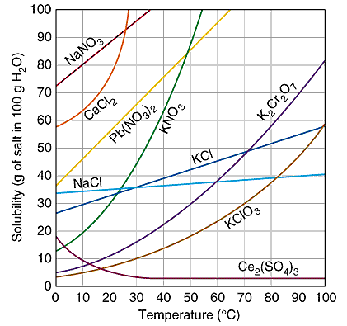
- Which is more likely to be soluble in hexane, C₆H₁₄. Why?:
  - CCl₄ or CaCl₂
  - Benzene (C₆H₆) or glycerol (CH₂(OH)CH(OH)CH₂OH
- A sulfuric acid solution containing 571.6g of H₂SO₄ per liter of solution. What is the molarity of the solution?
- Ascorbic acid (Vitamin C, C₆H₈O₆) is a water-soluble vitamin. A solution containing 80.5g of ascorbic acid is dissolved in 210g of water has a density of 1.22g/mL. What is the molarity?

Kinetics (ch 14)
- The rate of disappearance of HBr was measured for the following reaction:
CH₃OH (aq) + HBr (aq) CH₃Br (aq) + H₂O (l)
The following data were collected.
Time (min.) [HBr] (M)
0.0 1.85
54.0 1.58
107.0 1.36
215.0 1.02
430.0 0.580

  - Calculate the average rate of reaction, in M/min, for the time interval between each measurement.
  - Graph [HBr] versus time, and determine the instantaneous rates in M/min at t = 75.0 min and t = 250.0 min.
- Consider the following reaction: 2NO(g) + 2H₂(g) N₂(g) + 2H₂O(g)
  - The rate law for this reaction is first order in H₂ and second order in NO. Write the rate law.
  - If the rate constant for this reaction at 1000K is 6.0 × 10⁴ M⁻²s⁻¹, what is the rate of the reaction when [NO] is 0.035M and [H₂] is 0.015M?
- The iodide ion reacts with the hpochlorite ion in the following way: OCl⁻ + I⁻ OI⁻ + Cl⁻. The rapid reaction gives the following data:
[OCl⁻] [I⁻] Rate (M/s)
0.0015 0.0015 0.000136
0.0030 0.0015 0.000272
0.0015 0.0030 0.000272
  - Write the rate law for this reaction.
  - Calculate the rate constant.
  - Calculate the rate when [OCl⁻] = 2.0 × 10⁻³M and [I⁻] = 5.0 × 10⁻⁴M

- The gas phase decomposition of NO₂, 2NO₂(g) 2NO(g) + O₂(g), is studied at 383°C. The following information is given:
Time (s) [NO₂](M)
0 0.100
5.0 0.017
10.0 0.0090
15.0 0.0062
20.0 0.0047
  - Is the reaction first or second order with respect to the concentration of NO₂?
  - What is the value of the rate constant?
- A certain first order reaction has a rate constant of 2.75 × 10⁻²s⁻¹ at 20°C. What is the value of the k at 60°C if E_{a} = 75.5kJ/mol?
- The following mechanism has been proposed for the gas phase reaction of H₂ with ICl:
H₂ (g) + ICl(g) HI(g) + HCl(g)
HI(g) + ICl(g) I₂(g) + HCl(g)
  - Write the balanced equation for the overall reaction.
  - Identify any intermediates.
  - Write the rate laws for each elementary reaction in the mechanism.
  - If the first step is slow and the second one is fast, what rate law do you expect to be observed for the overall reaction?
- Given the following proposed mechanism:
Step 1: 2NO <-> N₂O₂ fast
Step 2: N₂O₂ + H₂ N₂O + H₂O slow
Step 3: N₂O + H₂ N₂ + H₂O fast
  - Determine the overall reaction.
  - What are the intermediates in this mechanism>
  - Determine the rate law.
  - What is the molecularity of the rate-determining step?

Equilibrium (ch 15)
- When the following reactions come to equilibrium, does the equilibrium mixture contain mostly reactants or products?
  - N₂(g) + O₂(g) 2NO(g) K_{c} = 1.5 × 10⁻¹⁰
  - 2SO₂(g) + O₂(g) 2SO₃(g) K_{p} = 2.5 × 10⁹
- A mixture of 0.10mol of NO, 0.050mol of H₂, and 0.10mol of H₂O is placed in a 1.0L vessel at 300K. The following equilibrium is established:
2NO(g) + 2H₂(g) <-> N₂(g) + 2H₂O(g)
At equilibrium [NO] is 0.062M.
  - Calculate the equilibrium concentrations of H₂, N₂, and H₂O.
  - Calculate K_{c}.
- For the equilibrium 2NO(g) <-> N₂(g) + O₂(g) at 2000°C, K_{c} = 2.4 × 10³. If the initial concentration of NO is 0.200M, what are the equilibrium concentrations of NO, N₂, and O₂?
- Consider the following equilibrium, for which ΔH < 0: 2SO₂(g) + O₂(g) <-> 2SO₃(g). How will each of these changes affect the equilibrium?
  - O₂ gas is added to the system.
  - The reaction mixture is heated.
  - The volume of the reaction vessel is doubled.
  - A catalyst is added to the mixture.
  - The total pressure of the system is increased by adding a noble gas.
  - SO₃(g) is removed from the system.

Acid/Base Equilbrium
- Complete the following table:
[H+] | [OH-] | pH | pOH | acidic or basic?
7.5 × 10⁻³
 | 3.6 × 10⁻¹⁰
 |  | 8.25
 |  |  | 5.70

- Name the 7 strong acids and 8 strong bases. What makes them strong?
- Saccharin, a sugar substitute, is a weak acid with a K_{a} = 0.00479. It ionized in aqueous solution as follows: HNC₇H₄SO₃(aq) <-> H⁺(aq) + NC₇H₄SO₃⁻(aq)
What is the pH of a 0.10M solution of this substance?

