What’s in a Mole? Lab

Purpose: To determine the number of formula units of calcium carbonate are in a piece of chalk.

Directions:
Choose a piece of chalk and find its mass. Then we will go outside and write/draw chemistry related items and solve problems outside. Once we come back in, we will find the mass of the chalk again and then determine how many molecules you used.

Acceptable chemistry related drawings.
Moles/ Mole Map
Using Elements tiles from the Periodic Table to make words (clean and appropriate here people!).
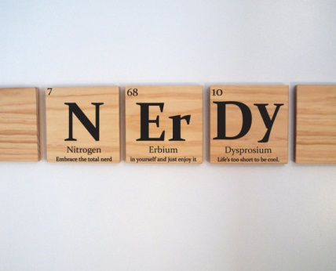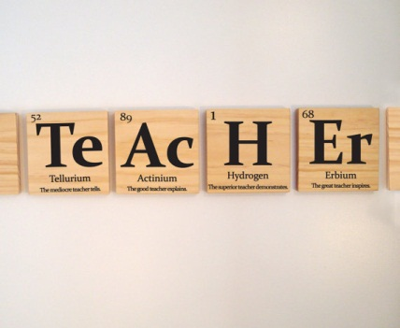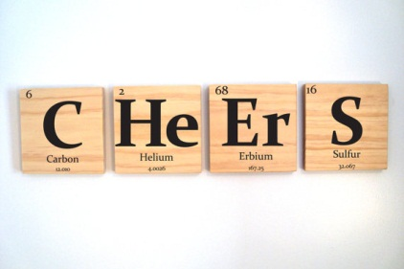
Problems to Solve:
- The chemical formula for tryptophan is C₁₁H₁₂N₂O_{2.} Tryptophan is the chemical n turkey most people mistakenly blame for making them sleepy after their Thanksgiving meal. The body uses tryptophan to make serotonin which is used to make melatonin, a hormone that helps control your sleep and wake cycles. One regular sized portion of turkey contains 0.333g of tryptophan, which is definitely not enough to make you fall asleep. How many molecules of tryptophan is that?

- Theobromine has the chemical formula C₇H₈N₄O₂. It is one of the primary chemicals found in chocolate. A one ounce serving of dark chocolate contains 6.682 × 10²⁰ molecules of theobromine. What is the mass of the theobromine, in grams?

- In the fall, leaves stop producing chlorophyll, a green pigment. Once the chlorophyll is diminished, the red, yellow, and orange pigments in the leaves can then be seen. Chlorophyll a has the formula, C₅₅H₇₂MgN₄O₅. If a leaf contains 0.000675g of chlorophyll, what is the number of molecules of chlorophyll?

