Unit Test Review KEY – Nuclear Chemistry & the Periodic Table

Nuclear Chemistry
- Describe nuclear fusion. Fusing together two smaller atoms to create a larger atoms and a “ton” of energy!

- Describe nuclear fission. Splitting a larger atoms into smaller atoms, also create a lot of energy but not as much as fusion.

- Which process releases more energy: fission or fusion?

- How are/were the elements from Helium to Iron created?
During a star’s lifetime, hydrogen atoms undergo fusion in the core and create He. When it runs out of H, it starts to fuse He into other elements.
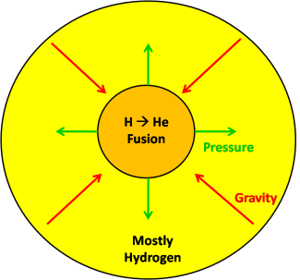

- How are/were the elements heavier than Iron created?
Once a star’s core has undergone fusion and iron is left, it doesn’t have enough energy to keep fusing heavier elements into existence. The star starts to collapse under its own gravity but the heat and pressure push it out into a supernova explosion. This supernova event gives the dying star enough energy to fuse the elements heavier than iron into existence.

The Periodic Table
- Label the following on the Periodic Table
  - Groups #1-18
  - Periods #1-7
  - 7 metalloids
  - Alkali metals
  - Alkaline earth metals
  - Transition metals
  - Inner transition metals
  - Halogens
  - Noble gases
1 2 3 4 5 6 7 8 9 10 11 12 13 14 15 16 17 18
1 | X |  |  |  |  |  |  |  |  |  |  |  |  |  |  |  |  | X
2 | X | X |  |  |  |  |  |  |  |  |  |  | B |  |  |  | X | X
3 | X | X |  |  |  |  |  |  |  |  |  |  |  | Si |  |  | X | X
4 | X | X | X | X | X | X | X | X | X | X | X | X |  | Ge | As |  | X | X
5 | X | X | X | X | X | X | X | X | X | X | X | X |  |  | Sb | Te | X | X
6 | X | X | X | X | X | X | X | X | X | X | X | X |  |  |  | Po | X | X
7 | X | X | X | X | X | X | X | X | X | X | X | X |  |  |  |  | X | X
 |  |  | X | X | X | X | X | X | X | X | X | X | X | X | X | X
 |  |  | X | X | X | X | X | X | X | X | X | X | X | X | X | X

- Define:
  - Atomic radius ½ the distance between the nuclei of two of the same atom.
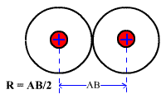

  - Ionic radius ½ the distance between the nuclei of two of the same ion.

  - Ionization energy the amount of energy needed to remove a valence electron from an atom

  - Electronegativity the attraction an atom’s nucleus has for another atom’s electrons.

- Which element has the highest atomic and ionic radius and the lowest ionization energy and lowest electronegativity? Why?
Francium (Fr) has the highest atomic and ionic radius and the lowest ionization energy and lowest electronegativity BECAUSE it’s valence electron is in the 7th energy level, farthest from the nucleus where the attraction between that valence electron and the nucleus is reduced- it’s so far away and there are all the electrons in the first 6 energy levels between them. Therefore the atom gets bigger AND it gets easier to remove that valence electron from the atom.

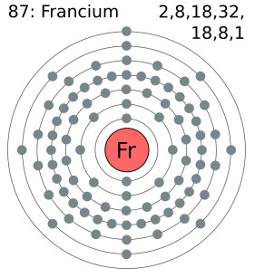

- Which element has the lowest atomic and ionic radius and the highest ionization energy and highest electronegativity? Why?
Fluorine has the smallest atomic and ionic radius and the highest ionization energy and highest electronegativity BECAUSE all 7 of its valence electrons are close to the nucleus in the 2nd energy level, which has 9 protons. There is a strong attraction between those protons in the nucleus and the valence electrons so they stay really close together, which makes for a very small radius. Since the valence electrons are so close to the nucleus, it takes a LOT of energy to remove one from the atom.

- Using your knowledge of periodic trends, arrange these elements (Al, O, Ba, and Fe) from…
  - Smallest to largest ionization energy Ba – Fe – Al - O

  - Largest to smallest atomic radius. Ba – Fe – Al - O

  - Smallest to largest ionic radius O – Al – Fe - Ba

  - Largest to smallest electronegativity O – Al – Fe - Ba

