Notes – Reaction Rates & Equilibrium
- Collision Theory – Reactions happen when reactants collide or .

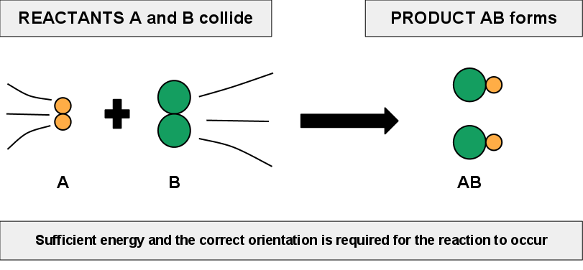
- Spontaneous reaction – occurs when the collision is enough that are broken & remade.
- Nonspontaneous reaction – If there is not enough and we have to add some in the form of , , or .
- There must be enough energy for the reaction to start, called energy.

.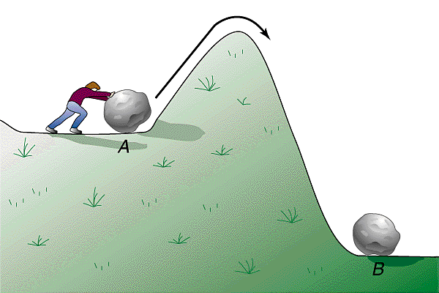 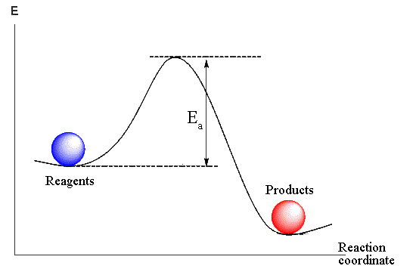

- Reaction Rate – How fast a reaction moves from reactants to products
  - What can change the rate of a reaction?
    - . . the temperature
      - Why?
    - Increasing the of reactants
      - Why?
    - Adding a catalyst
      - What is a catalyst?
        - A substance whose mere presence speeds up a reaction without being involved in the reaction at all!
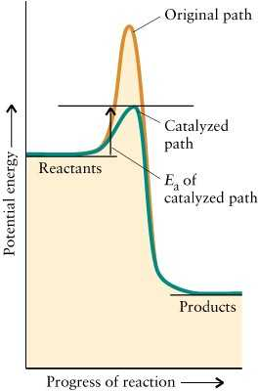

- Equilibrium
  - Reversible Reactions – a reaction that proceed from reactants to products and then reverse and go from products to reactants
    - 2H₂ + O₂ → 2H₂O forward reaction

    - 2H₂ + O₂ ← 2H₂O reverse reaction

    - Becomes

  - Equilibrium –
Rate of forward reaction = rate of the reverse reaction

  - LeChatelier’s Principle – when a change is forced on the system at equilibrium, the position of equilibrium shifts (to the or to the ) to reduce the effect of the change.
    - Examples
      - N₂ (g) + 3H₂ (g) ⇄ 2NH₃ (g)
        - Which way would equilibrium shift if you
          - Increased the concentration of N₂?
          - Increased the concentration of NH₃?
          - Reduced the concentration of H₂?
      - CaCO₃ (s) ⇄ CaO (s) + CO₂ (g)
        - Which way would equilibrium shift if you
          - Decreased the volume of the container?
          - Increased the volume of the container?
      - N₂ (g) + 3H₂ (g) ⇄ 2NH₃ (g) + 92kJ
        - Which way would equilibrium shift if you
          - Increased the temperature?
          - Decreased the temperature?
          - Reduced the concentration of H₂?
      - CaCO₃ (s) + 556kJ ⇄ CaO (s) + CO₂ (g)
        - Which way would equilibrium shift if you
          - Increased the temperature?
          - Reduced the temperature?

