CW #4 – Nuclear Chemistry

Directions: Identify each as a fusion , fission , or both kinds of reactions:

1. Used in nuclear power plants:

2. Occurs on the sun:

3. More power per gram:

4. A larger nucleus divides to make a smaller nucleus:

5. Two hydrogen atoms fuse to make a helium atom: ______________________________
6. A critical mass is necessary to explode: _________________________________

7. 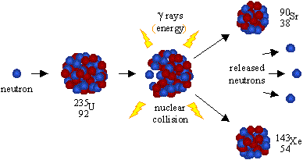 :

8. An atomic bomb: ____________________________

9. are used in nuclear power plants to keep the reaction under control.

10. Why can’t we use fusion reaction in a nuclear power plant? _____________

11. What is the downside to fission reactions used in power plants? ________________________

12. How is electricity generated from nuclear power plants? ________

